**SOLDIER HEALTH AND POSITION TRACKING SYSTEM**

**Abstract:**

In today’s world the security of the nation is depends upon the enemies’ warfare and so the safety of the soldiers is considered as vital role in it. A country’s arm forces consist of three professional uniformed services: the army, the navy, and the air force. Concerning the soldier’s safety there are many instruments to view their health status as well as ammunitions on the soldiers. To overcome the safety concern, we had built this project which using wireless body area sensor network such as temperature sensor, heartbeat sensor etc will monitor the health status of the soldier whenever required. Also using GPS, we can track the soldier’s exact location whenever required. These devices are being added to weapons, firearms, and militaries such as the Israeli an Army which are exploring the possibility of embedding GPS devices into soldiers vests and uniforms so that field commanders can track their soldier’s movements in real time GSM module can be used for effective range of high-speed transmission, short range and soldier-to-soldier wireless communications that will be required to relay information on situational awareness, tactical instructions, and covert surveillance related data during special operations reconnaissance and other missions. By using all this equipment’s we had tried to implement the basic guarding system for the soldier in low cost, light weighted, portable and precise device. In today’s world enemy warfare is an important factor in any nation’s security. The important and vital role is played by the army soldier’s. There are many concerns regarding the safety of these soldiers. In our project we have come up with an idea of tracking the soldier as well as to give the health status of the soldier during the war, which enables the army personnel to plan the war strategies. By using the location sent by the GPS modem, the base station can understand the position of soldier.

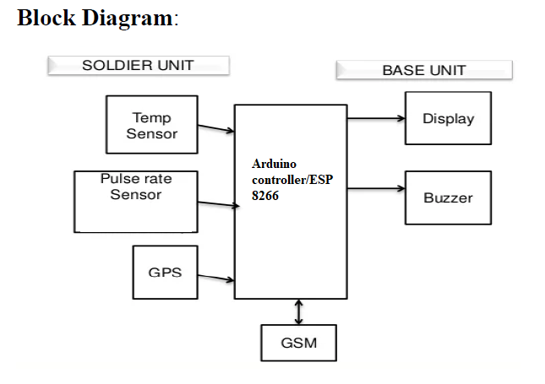

**System requirements:**

**Hardware :**

1. Arduino nano
2. Temperature sensor
3. GSM
4. GPS
5. LCD display
6. Buzzer
7. Pulse rate sensor
8. Temperature sensor
9. Power supply
10. Capacitor
11. Potentiometer
12. Resistor
13. BC547
14. Jumper wires

**Software:**

1.Arduino IDE

2.Embedded C

**CHAPTER-I**

**1. Introduction:**

The trooper must be coordinated with cutting edge medicinal services observing, continuous GPS (Global Positioning System) and information interchanges to send and get data to/from the control unit. For that Soldier may require remote systems not exclusively to speak with control unit yet in addition with one next to the other military staff. Aside from the country's security, the warrior must need wellbeing by ensuring himself with cutting edge weapons and it is fundamental for the military control unit to screen the wellbeing status of the officer. To fill this need, in this paper bio therapeutic sensors and checking gadgets are incorporated with the officers. The incorporated parts must be light weight bundle and should give wanted outcome without requiring much power. One of the major difficulties in military activities lies that the officers are not ready to speak with control unit. What's more, the best possible route between fighters assumes a significant job for cautious arranging and co-appointment. Thus, the proposed work centers around following the area of fighter which is valuable for control room station to know the careful area of officer and as needs be they will direct them. Control unit gets area of warrior utilizing GPS. It is essential for the base station to direct the trooper on right way in the event that he lost in the war zone. This paper will be valuable for the fighters, who include in exceptional activities or missions. Shrewd Bio restorative sensors including Heartbeat sensor, Temperature and Humidity sensor, Vibration sensor, bomb identifier and so on., are appended to the coat of fighters. These are embedded with the trooper for complete portability. This framework will give availability to the server at the base station utilizing a remote association. The information gathered at the base station can be utilized for further forecast calculation. This may enable the control to station to think about the circumstance at the mission field The nation’s security is monitored and kept by army, navy and air-force. The important and vital role is of soldiers who sacrifice their life for their country. There are many concerns regarding the safety of the soldier. Soldiers entering the enemy lines often lose their lives due to lack of connectivity, it is very vital for the army base station to known the location as well as health status of all soldiers. India has already lost so many soldiers in war-fields as there was no proper health backup and connectivity between the soldiers on the war-fields and the officials at the army base stations. Recently on 29 September 2016, a military confrontation between India and Pakistan began; Indian soldiers conducted a surgical strike against militant launch pads across the line of control in Pakistani-administered Azad Kashmir, and inflicted “significant causalities”. Indian soldiers are mainly known for their courage, in spite of scarce ammunitions and safety measures; they have many triumphs to their credits. All must be really concerned about the safety of the soldiers, so we have decided to build a project which will efficiently keep a check on the health status of the soldier, and his precise location to equip him with necessary medical treatments as soon as possible. Soldier’s tracking is done using GPS and GSM is used to provide wireless communication system. For monitoring the health parameters of soldier we are using bio medical sensors such as temperature sensor and heart beat sensor. An oxygen level sensor is used to monitor atmospheric oxygen so if there are any climatic changes the soldiers will be equipped accordingly. So this paper focuses on tracking the location of soldier from GPS, which is useful for control room station to know the exact location of soldier and accordingly they will guide them and it is for Highspeed, short range, soldier-to-soldier wireless communications to relay information on situational awareness with Bio-medical sensors, GPS navigation.

**1.1.Working principle:**

The main intention of this project is to find out the exact location of the injured solider in the war field. This GSM based solider health and position tracking system retrieves the exact location of a soldier in terms of its longitude and latitude. This data is fed to the Arduino, which is interfaced to a GSM modem. The Arduino retrieves the exact location details from the GPS and sends an SMS to the concerned authority over GSM modem. An LCD display is connected to the Arduino for crossing the data received before being sent over GSM. This project will be very useful to army base station to keep track of their soldiers.

**1.2.Literature review:**

During, wars and military search operations, soldiers gets injured and sometime becomes losses. To find soldiers and provide health monitoring, army base station and need GPS device for locating soldiers, WBASNs to sense health related parameters of soldiers and a wireless transceiver to transmit the data wirelessly. Hong Beng Lim, Di Ma, Bang Wang, ZbigniewKalbarczyk, Ravishankar k. Lyer, Kenneth L. Watkin has discussed on recent advantage in growing technology, and on various wearable, portable ,light weighted and small sized sensor that have been developed for monitoring of the human physiological parameters .The body sensor network (BSN) consists of many biomedical and physiological sensors such as blood pressure sensors , Electrocardiogram (ECG) sensor, electr dermal activity (EDA) sensor which can be placed on human body for health monitoring in real time [1]. Shruti Nikam, SupriyaPatil, Prajkta Power, V.S. Bendre [3] had presented an idea for the safety of soldiers. There are many instruments which can be used to view the health status of soldiers as well as ammunitions on them. The Bio sensor which consist of various types of small physiological sensors, transmission modules have great processing capabilities and can facilitates the low-Cost wearable solutions for health monitoring. Also as stated by Dinesh Kumar Jaiswar, Sanjana S Repal in their survey, P.S. Kurhe ,S.S Agrawal had introduced a system that gives ability to track the soldiers at any moment additionally ,the soldiers will be able to communicated with control room using GPS coordinate in their distress. The location tracking has great importance since World War II, when military forces realized its usefulness for navigation, positioning, targeting and fleet management. This system is reliable, energy efficient for remote soldier health monitoring and their location tracking. It is able to send the sensed and processed parameters of soldier in real time. It enables to army control room to monitor health parameters of soldiers like heart beat, body temperature, etc. using body sensor networks. The parameters of soldiers are measured continuously and wirelessly transmitted using GSM

**1.3.Existing system:**

Existing System that monitors the health of the soldier, Navigation system is used for two way short message communication.

**1.4.Proposed System:**

The proposed system consist of microcontroller along with temperature sensor, Heartbeat sensor, Buzzer, LCD, GPS, GSM modem. The microcontroller used control all the signals and activities in the soldier unit.

**1.5. EMBEDDED SYSTEMS**

**DEFINITIONS :**

Embedded system is a combination of hardware and software, it is also named as “Firm ware”. An embedded system is a special purpose computer system, which is completely encapsulated by the device it controls. It is a computer-controlled system. An embedded system is a specialized system that is a part of a larger system or machine. As a part of a larger system it largely determines its functionality. Embedded systems are electronic devices that incorporate microprocessors with in their implementations. The main purpose of the microprocessors are simplify the system design and improve flexibility. In the embedded systems, the software is often stored in a read only memory (RAM) chip. Embedded systems provide several major functions including monitoring of the analog environment by reading data from sensors and controlling actuators.

The general purpose definition of embedded system is that they are devices used to control, monitor or assist the operation of equipment, machinery or plant. “Embedded” reflects the fact that they are an integral part of the system. All embedded systems are including computers or microcontrollers. Some of these computers are however very simple systems as compared with a personal computer. The very simple embedded systems are capable of performing only a simple function or set of function to meet a single predetermine purpose. In more complex systems an application program that enables the embedded system to the used for a particular purpose in a specific application determines the functioning of the embedded system the ability to have a program means that the same embedded system can be used for variety of different purpose. Controller input comes from a detector or sensor and its output goes to a switch oractivator which (for example) may start or stop the operation of a machine.

EXAMPLES OF EMBEDDED SYSTEMS:

Embedded systems are found in wide range of application areas. Originally they were used only for expensive industrial control applications, but as technology brought down the cost of dedicated processors, they began to appear in moderately expensive applications such as automobiles, communication and office equipments and television Today's embedded systems are so inexpensive that they are used in almost every electronic product in our life. Embedded systems are often designed for mass production.

Some examples of embedded systems:

* Automatic Teller Machines
* Cellular telephone and telephone switches
* Computer network equipment
* Computer printers
* Disk drives
* Engine controllers and antilock break controllers for automobiles
* Home automation products
* Handheld calculators
* Household appliances
* Medical equipment
* Measurement equipment
* Multifunction wrist watches
* Multifunction printers

**1.6. SYSTEM STUDY**

**FEASIBILITY STUDY**

The feasibility of the project is analyzed in this phase and business proposal is put forth with a very general plan for the project and some cost estimates. During system analysis the feasibility study of the proposed system is to be carried out. This is to ensure that the proposed system is not a burden to the company. For feasibility analysis, some understanding of the major requirements for the system is essential.

Three key considerations involved in the feasibility analysis are

* ECONOMICAL FEASIBILITY
* TECHNICAL FEASIBILITY
* SOCIAL FEASIBILITY

**ECONOMICAL FEASIBILITY**

This study is carried out to check the economic impact that the system will have on the organization. The amount of fund that the company can pour into the research and development of the system is limited. The expenditures must be justified. Thus the developed system as well within the budget and this was achieved because most of the technologies used are freely available. Only the customized products had to be purchased.

### TECHNICAL FEASIBILITY

This study is carried out to check the technical feasibility, that is, the technical requirements of the system. Any system developed must not have a high demand on the available technical resources. This will lead to high demands on the available technical resources. This will lead to high demands being placed on the client. The developed system must have a modest requirement, as only minimal or null changes are required for implementing this system.

**SOCIAL FEASIBILITY**

The aspect of study is to check the level of acceptance of the system by the user. This includes the process of training the user to use the system efficiently. The user must not feel threatened by the system, instead must accept it as a necessity. The level of acceptance by the users solely depends on the methods that are employed to educate the user about the system and to make him familiar with it. His level of confidence must be raised so that he is also able to make some constructive criticism, which is welcomed, as he is the final user of the system.

**CHAPTER-II**

**2. HARDWARE DESCRIPTION:**

**2.1.Arduino Nano:**

Arduino is an open-source prototyping platform based on easy-to-use hardware and software. Arduino boards are able to read inputs - light on a sensor, a finger on a button, or a Twitter message - and turn it into an output - activating a motor, turning on an LED, publishing something online. You can tell your board what to do by sending a set of instructions to the microcontroller on the board. It is like the brain of a project.

Because it is so flexible and open source, Arduino is the best solution if you are interested in creating interactive objects or environments no matter you are artists, designers or hobbyists.

One of Seeed Studio’s motto is “Grow the Difference”, which has now become part of the culture of the company. This is not just reflected from what we are doing in popularizing open source culture, but also from our products. Ever since the company funded, we are continuously creating our own open platform to differentiate from the existing one.

Here at Seeed, you can find not only Arduino boards, such such as Arduino Nano and Arduino Mega, but also many boards that derived from Arduino such as Seeeduino, a joint effort by Seeed Studio and Arduino. Seeeduino is compatible with Arduino while has more powerful functions and lower price. To start with, you can try the latest version Seeeduino V4.2 or Seeeduino Mega that corresponding to Arduino Mega.

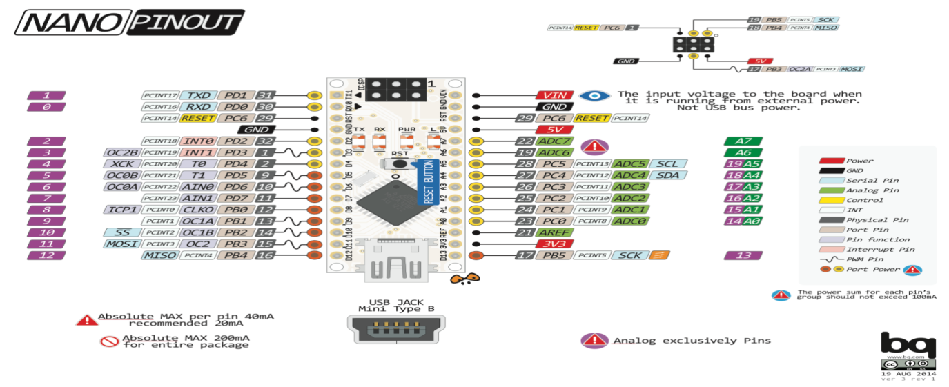

Fig. Arduino nano pin out

[Arduino](http://arduino.cc/) is an open-source platform used for building electronics projects. Arduino consists of both a physical programmable circuit board (often referred to as a [microcontroller](http://en.wikipedia.org/wiki/Microcontroller)) and a piece of [software](http://arduino.cc/en/Main/Software), or IDE (Integrated Development Environment) that runs on your computer, used to write and upload computer code to the physical board.

The Arduino platform has become quite popular with people just starting out with electronics, and for good reason. Unlike most previous programmable circuit boards, the Arduino does not need a separate piece of hardware (called a programmer) in order to load new code onto the board – you can simply use a USB cable. Additionally, the Arduino IDE uses a simplified version of C++, making it easier to learn to program. Finally, Arduino provides a standard form factor that breaks out the functions of the micro-controller into a more accessible package.

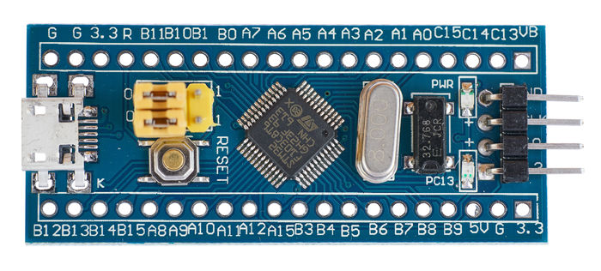

* The micro-USB connector is not soldered to the board very well and is easily broken.

There are multiple versions of this board with different connectors. Refer to the pictures for examples. You can increase the strength by re-soldering the connector and possibly covering the connector in epoxy glue or hot-melt glue.

* The 3.3V voltage regulator is a very small, knock-off device. It overheats quickly and often has no thermal protection, feeding through its input voltage when it fails.

It's recommended to power external components with another regulator so that the power draw on the Blue Pill does not exceed 100 mA.

* Analogue power and ground is connected directly to digital power and ground, which can cause additional noise on the ADC input.
* The reset button on some of these boards is very hard to press.
* There is no dedicated USB reset circuitry on this board.
* There is no Schottky diode between USB +5V and system VIN power. So you cannot power the board directly from a 5 Volt supply, and use USB at the same time.
* Most bluepill boards have the wrong pullup resistor value which prevents native USB from working properly. The R10 resistor should have a value of 1k5 and be pulled up to 3v3. In spite of this flaw, native USB will work on some PCs. Try the board on your PC before you bother changing the resistor.
* Microcontroller:- most of the arduino board makes use of Atmel AVR. Microcontroller is the place where all your codes stored and executed.Microcontroller used in most coomonly used arduino UNO is the ATmega328p.
* Pins:- these pins are used to make connections with sensors and module.Common pins on arduino boads are 5V, 3.3V, GND, Digital, PWM, Analog, AREF.
* Power supply and USB:- USB is used to upload the code onto your arduino board along with it you can power your arduino board via USB but it might not be always handy to power your arduino with USB in that case you can use barrel jack which is provided for power supply.A power supply anywhere between 6-12 volt will be good to power your arduino.
* Reset button:- this button is used to restart your arduino and make it to run the code from the beginning.
* Power LED indicator:- on the arduino board you will find a LED just next to 'ON' this LED glows when you connect your arduino to a power supply.If this LED does not glow either there is problem in the board or you have not connected the arduino board with power supply properly.
* RX and TX LED:- first of all RX and TX is short term for receive and transmit respectively.When ever there is data transfer while uploading code or communicating with bluetooth module etc these LED glow.
* Voltage regulator:- this controls the amount of voltage which is let into arduino by turning away extra voltage which may dame our board.This regulator also has a limit so Do Not burn up arduino by supplying power more than 20 volts.

Arduino clones:

* There are many clone version of arduino which are way cheaper than the original board.I would recommend a clone arduino for beginners as it serves the same purpose but at lower cost.Once you are familiar with it you can go for original made in Italy arduino boards.

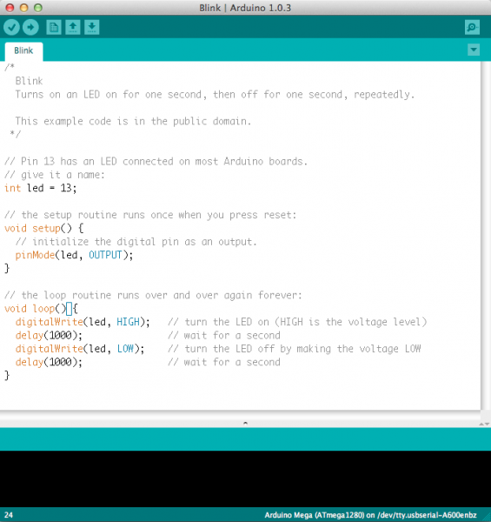

`The Arduino Nano is a small, complete, and breadboard-friendly board based on the ATmega328 (Arduino Nano 3.0) or ATmega168 (Arduino Nano 2.x). It has more or less the same functionality of the Arduino Duemilanove, but in a different package. It lacks only a DC power jack, and works with a Mini-B USB cable instead of a standard one. The Nano was designed and is being produced by Gravitech. The Nano 328 is a small, complete, and breadboard-friendly board based on the ATmega328 (Arduino Nano 3.0) or ATmega168 (Arduino Nano 2.x).It have an integrated on-board USB. As the function, It has almost all the analog and digital pins that the UNO or Duemilanove has and the same function as Duemilanove or UNO. This Nano 328(Arduino compatible) can go with the IO Shield for Arduino Nano, it would be more friendly and convenient for users to enter the Arduino world and make use of Arduino to make their dream into reality.  
As an upgrade version of Arduino Nano, This Nano 328 is 100% compatible to Arduino Nano and its shield and IDEs. On the hardware part, remarkable changes are taken to improve the flexibility and user experience. The Arduino Nano is a small, complete, and breadboard-friendly board based on the ATmega328P (Arduino Nano 3.x). It has more or less the same functionality of the Arduino Duemilanove, but in a different package. It lacks only a DC power jack, and works with a Mini-B USB cable instead of a standard one.

 Arduino is an [open-source hardware](https://en.wikipedia.org/wiki/Open-source_hardware) and [software](https://en.wikipedia.org/wiki/Open-source_software) company, project and user community that designs and manufactures [single-board microcontrollers](https://en.wikipedia.org/wiki/Single-board_microcontroller) and [microcontroller](https://en.wikipedia.org/wiki/Microcontroller) kits for building digital devices and interactive objects that can sense and control both physically and digitally. Its products are licensed under the [GNU Lesser General Public License](https://en.wikipedia.org/wiki/GNU_Lesser_General_Public_License) (LGPL) or the [GNU General Public License](https://en.wikipedia.org/wiki/GNU_General_Public_License)(GPL),[[1]](https://en.wikipedia.org/wiki/Arduino#cite_note-1) permitting the manufacture of Arduino boards and software distribution by anyone. Arduino boards are available commercially in preassembled form or as [do-it-yourself](https://en.wikipedia.org/wiki/Do-it-yourself) (DIY) kits.

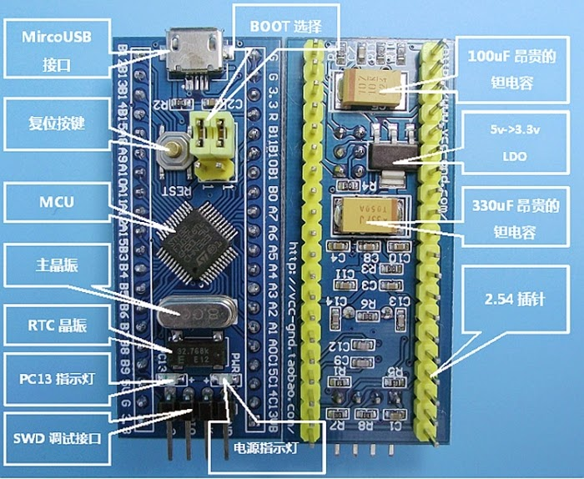

Arduino board designs use a variety of microprocessors and controllers. The boards are equipped with sets of digital and analog [input/output](https://en.wikipedia.org/wiki/Input/output) (I/O) pins that may be interfaced to various expansion boards or [breadboards](https://en.wikipedia.org/wiki/Breadboards) (*shields*) and other circuits. The boards feature serial communications interfaces, including [Universal Serial Bus](https://en.wikipedia.org/wiki/Universal_Serial_Bus) (USB) on some models, which are also used for loading programs from personal computers. The microcontrollers are typically programmed using a dialect of features from the programming languages [C](https://en.wikipedia.org/wiki/C_(programming_language)) and [C++](https://en.wikipedia.org/wiki/C%2B%2B). In addition to using traditional [compiler](https://en.wikipedia.org/wiki/Compiler) [toolchains](https://en.wikipedia.org/wiki/Toolchains" \o "Toolchains), the Arduino project provides an [integrated development environment](https://en.wikipedia.org/wiki/Integrated_development_environment) (IDE) based on the [Processing](https://en.wikipedia.org/wiki/Processing_(programming_language)) language project.

The Arduino project started in 2003 as a program for students at the [Interaction Design Institute Ivrea](https://en.wikipedia.org/wiki/Interaction_Design_Institute_Ivrea) in [Ivrea](https://en.wikipedia.org/wiki/Ivrea" \o "Ivrea), Italy, aiming to provide a low-cost and easy way for novices and professionals to create devices that interact with their environment using [sensors](https://en.wikipedia.org/wiki/Sensor) and [actuators](https://en.wikipedia.org/wiki/Actuator). Common examples of such devices intended for beginner hobbyists include simple [robots](https://en.wikipedia.org/wiki/Robot), [thermostats](https://en.wikipedia.org/wiki/Thermostat) and [motion detectors](https://en.wikipedia.org/wiki/Motion_detector).

The name *Arduino* comes from a bar in [Ivrea](https://en.wikipedia.org/wiki/Ivrea" \o "Ivrea), Italy, where some of the founders of the project used to meet. The bar was named after [Arduin of Ivrea](https://en.wikipedia.org/wiki/Arduin_of_Ivrea" \o "Arduin of Ivrea), who was the [margrave](https://en.wikipedia.org/wiki/Margrave) of the [March of Ivrea](https://en.wikipedia.org/wiki/March_of_Ivrea) and [King of Italy](https://en.wikipedia.org/wiki/King_of_Italy) from 1002 to 1014

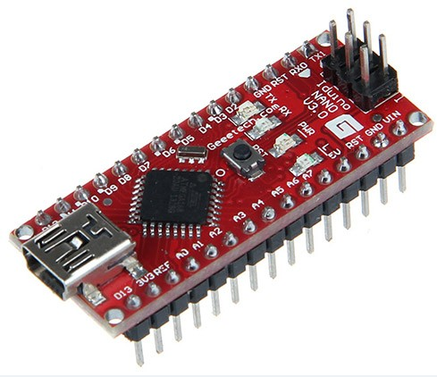

Arduino Nano 2.3 (ATmega168): [manual](http://arduino.cc/en/uploads/Main/ArduinoNanoManual23.pdf) (pdf), [Eagle files](http://gravitech.us/Arduino/Arduino_Nano_V2_3_Eagle.zip). Note: since the free version of Eagle does not handle more than 2 layers, and this version of the Nano is 4 layers, it is published here unrouted, so users can open and use it in the free version of Eagle. The Xduino Nano is a surface mount breadboard compatible version of the ever-popular Arduino micro controller. It's small, with integrated on-board USB, and is breadboard friendly. As the function, It has almost all the analog and digital pins that the UNO or Duemilanove has and the same function as Duemilanove or UNO. With the smaller and portable package, Xduino Nano would be more friendly and convenient for users to enter the Arduino world and make use of Arduino to make their dream into reality.   
As a upgrade version of Arduino Nano, the Xduino Nano is 100% compatible to Arduino Nano and its shield and IDEs. On the hardware part, remarkable changes are taken to improve the flexibility and user experience.

**Specifications:**

Microcontroller Atmel ATmega168 or ATmega328

Operating Voltage: (logic level) 5 V

Input Voltage: (recommended) 7-12 V

Input Voltage: (limits) 6-20 V

Digital I/O Pins: 14 (of which 6 provide PWM output)

Analog Input Pins: 8

DC Current per I/O Pin: 40 mA

Flash Memory: 16 KB (ATmega168) or 32 KB (ATmega328) of which 2 KB used by bootloader

SRAM: 1 KB (ATmega168) or 2 KB (ATmega328)

EEPROM: 512 bytes (ATmega168) or 1 KB (ATmega328)

Clock Speed: 16 MHz

Dimensions: 0.73" x 1.70"

Features

1. Power OK blue LED, RST red LED for reset the Nano.
2. Green (TX), red (RX) and orange (L) LED
3. Upgraded 5V voltage sourcing, more powerful drive capability.
4. Mini-B USB for programming and serial monitor, TX&RX breakout for application as USB-UART convertor.
5. Surface-Mount ICSP header
6. Standard 0.1” spacing DIP (Breadboard Friendly)
7. Power OK red LED, Green (TX), green (RX) and green (L) LED
8. Upgraded 5V voltage sourcing, more powerful drive capability
9. Mini-B USB for programming and serial monitor, TX&RX breakout for application as USB-UART convertor
10. Surface-Mount ICSP header

Standard 2.54mm spacing DIP (breadboard friendly)

|  |  |  |  |  |
| --- | --- | --- | --- | --- |
| Item | Min | Typical | Max | Unit |
| Microcontroller | Atmega328&Atmega168 | | | / |
| Operating Voltage (logic level) | 4.5 | 5.0 | 5.5 | VDC |
| Input Voltage(Recommended) | 7 | 9 | 12 | V |
| Digital I/O Pins | 14(Of which 6 provide PWM Output) | | | / |
| Analog Input Pins | 8 | | | / |
| DC Current per I/O Pin | 40 | | | mA |
| Flash Memory | 32KB(Atmega328);16KB(Atmefa168) | | | / |
| SRAM | 2 | | | KB |
| EEPROM | 1 | | | KB |
| Clock Speed | 16 | | | MHz |
| Dimensions | 7.0x 17.0 | | | mm |
| Weight |  | | | g |

## Usage

1.Atmega328, with more flash and ram memory.  
2. A RST LED added to show user the RST state; While all the package of LEDs upgraded.  
3.A0-A7 pins compatible with Arduino Stamp and Pro Mini.  
4. Upgrade of Power supply circuit with AMS117

### Power

The Xduino Nano can be powered via the mini-B USB connection or 6-20V unregulated external power supply (pin 30), or 5V regulated external power supply (pin 27). The power source is automatically selected to the highest voltage source. Also the Xduino Nano upgraded the power source circuit with a new IC AM117. This IC can supply a larger current than the previous IC 78M05 used in Arduino Nano, with this IC, the Xduino Nano can be compatible for more modules that may needs a larger current such as the GPRS module. The Arduino Nano can be powered via the Mini-B USB connection, 6-20V unregulated external power supply (pin 30), or 5V regulated external power supply (pin 27). The power source is automatically selected to the highest voltage source. The Arduino Nano can be powered via the Mini-B USB connection, 6-20V unregulated external power supply (pin 30), or 5V regulated external power supply (pin 27). The power source is automatically selected to the highest voltage source.

The FTDI FT232RL chip on the Nano is only powered if the board is being powered over USB. As a result, when running on external (non-USB) power, the 3.3V output (which is supplied by the FTDI chip) is not available and the RX and TX LEDs will flicker if digital pins 0 or 1 are high.

The FTDI FT232RL chip on the Nano is only powered if the board is being powered over USB. As a result, when running on external (non-USB) power, the 3.3V output (which is supplied by the FTDI chip) is not available and the RX and TX LEDs will flicker if digital pins 0 or 1 are high.

**Memory:**

The ATmega168 has 16 KB of flash memory for storing code (of which 2 KB is used for the bootloader); the ATmega328 has 32 KB, (also with 2 KB used for the bootloader). The ATmega168 has 1 KB of SRAM and 512 bytes of EEPROM (which can be read and written with the EEPROM library); the ATmega328 has 2 KB of SRAM and 1 KB of EEPROM. The ATmega328 has 32 KB, (also with 2 KB used for the bootloader) and has 2 KB of SRAM and 1 KB of EEPROM. The ATmega168 has 16 KB of flash memory for storing code (of which 2 KB is used for the bootloader); the ATmega328 has 32 KB, (also with 2 KB used for the bootloader). The ATmega168 has 1 KB of SRAM and 512 bytes of EEPROM (which can be read and written with the EEPROM library); the ATmega328 has 2 KB of SRAM and 1 KB of EEPROM.

### Input and Output:

Each of the 14 digital pins on the Nano can be used as digital input or output, using pinMode(), digitalWrite(), and digitalRead() functions. They operate at 5 volts. Each pin can provide or receive a maximum of 40 mA and has an internal pull-up resistor (disconnected by default) of 20-50 kOhms. In addition, some pins have specialized functions:   
Serial: 0(RX) and 1 (TX). Can be used to receive (RX) and transmit (TX) TTL serial data. These pins are connected to the corresponding pins of the FTDI USB-to-TTL Serial chip.   
External Interrupts: 2 and 3.These pins can be configured to trigger an interrupt on a low value, a rising or falling edge, or a change in value.  
PWM: 3, 5, 6, 9, 10, and 11.Provide 8-bit PWM output with the analogWrite() function.   
SPI: 10 (SS), 11 (MOSI), 12 (MISO), 13 (SCK). These pins support SPI communication.  
LED: 13. There is a built-in LED connected to digital pin 13. When the pin is HIGH value, the LED is on, when the pin is LOW, it's off. This LED can be used as an indicator when in the first step of Xduino Nano.

The Nano has 8 analog inputs, each of which provide 10 bits of resolution (i.e. 1024 different values). By default they measure from ground to 5 volts, it is also possible to change the upper end of their range using the analogReference() function. Additionally, some pins have

specialized functionality:

I2C: 4 (SDA) and 5 (SCL). These two pins Support I2C (TWI) communication using the Wire library (documentation on the Wiring website). There are a couple of other pins on the board:  AREF. Reference voltage inputs for the analogread(). Used with analogReference().   
Reset.Bring this line LOW to reset the microcontroller. This is a Reset button on the Xduino Nano, and, users can add another reset source by wiring to the source you want.

### Programming:

Each of the 14 digital pins on the Nano can be used as an input or output, using pinMode(), digitalWrite(), and digitalRead() functions. They operate at 5 volts. Each pin can provide or receive a maximum of 40 mA and has an internal pull-up resistor (disconnected by default) of 20-50 kOhms. In addition, some pins have specialized functions: Serial: 0 (RX) and 1 (TX). Used to receive (RX) and transmit (TX) TTL serial data. These pins are connected to the corresponding pins of the FTDI USB-to-TTL Serial chip. External Interrupts: 2 and 3. These pins can be configured to trigger an interrupt on a low value, a rising or falling edge, or a change in value. See the attachInterrupt() function for details.

PWM: 3, 5, 6, 9, 10, and 11. Provide 8-bit PWM output with the analogWrite() function.

SPI: 10 (SS), 11 (MOSI), 12 (MISO), 13 (SCK). These pins support SPI communication, which, although provided by the underlying hardware, is not currently included in the Arduino language.

LED: 13. There is a built-in LED connected to digital pin 13. When the pin is HIGH value, the LED is on, when the pin is LOW, it's off. The Arduino Nano can be programmed with the Arduino software (download). Select "Arduino Diecimila, Duemilanove, or Nano w/ ATmega168" or "Arduino Duemilanove or Nano w/ ATmega328" from the Tools > Board menu (according to the microcontroller on your board). For details, see the reference and tutorials.

The ATmega168 or ATmega328 on the Arduino Nano comes preburned with a bootloader that allows you to upload new code to it without the use of an external hardware programmer. It communicates using the original STK500 protocol (reference, C header files).

You can also bypass the bootloader and program the microcontroller through the ICSP (In-Circuit Serial Programming) header; see these instructions for details.

The Nano has 8 analog inputs, each of which provide 10 bits of resolution (i.e. 1024 different values). By default they measure from ground to 5 volts, though is it possible to change the upper end of their range using the analogReference() function. Additionally, some pins have specialized functionality:

* I2C: 4 (SDA) and 5 (SCL). Support I2C (TWI) communication using the Wire library (documentation on the Wiring website). There are a couple of other pins on the board:
* AREF. Reference voltage for the analog inputs. Used with analogReference().
* Reset. Bring this line LOW to reset the microcontroller. Typically used to add a reset button to shields which block the one on the board.

See also the mapping between Arduino pins and ATmega168 ports.

The Elecrow Arduino Nano can be programmed with the Arduino software (Version higher than 1.o was suggested). Select "Arduino Duemilanove or Nano w/ ATmega328" from the Tools > Board menu (according to the microcontroller on your board).   
The ATmega328 on the Xduino Nano comes preburned with a bootloader that allows you to upload new code to it without the use of an external hardware programmer.   
You can also bypass the bootloader and program the microcontroller through the ICSP (In-Circuit Serial Programming) header.

### TX& RX Pins other Usage:

The Elecrom Arduino also breakout the TX&RX pins of FTDI IC, this makes the Nano can working as a normal USB-UART convertor. If you needs a USB-UART convertor in your application, for example, you want to connect your zigbee module to PC via the USB connector, you can connect the TX pin of Zigbee to the TXD breakout hole and connect the RX pin of zigbee to RXD breakout hole. In this way, the FTDI IC on Elecrom Arduino Nano converts the USB signal to UART signal, the zigbee can communicate with the PC. Resistors are added to avoid signal confusion, when these two pins were connected to other module, the UART signal would not be affected by the Atmega328 on Elecrom Arduino Nano. Notice: “TXD” on Elecrom Arduino Nano means: UART side sent signal and USB side receive; while the “RXD”means: UART side receive signal while USB side sent

**Microcontroller**:- most of the arduino board makes use of Atmel AVR. Microcontroller is the place where all your codes stored and executed.Microcontroller used in most coomonly used arduino UNO is the ATmega328p.

Pins:- these pins are used to make connections with sensors and module.Common pins on arduino boads are 5V, 3.3V, GND, Digital, PWM, Analog, AREF.

Power supply and USB:- USB is used to upload the code onto your arduino board along with it you can power your arduino board via USB but it might not be always handy to power your arduino with USB in that case you can use barrel jack which is provided for power supply.A power supply anywhere between 6-12 volt will be good to power your arduino.

(Note:-Do Not use a power supply greater than 20 volt which might overpower your arduino and destroy it.)

**Reset button:-** this button is used to restart your arduino and make it to run the code from the beginning.  
**Power LED indicator:-** on the arduino board you will find a LED just next to 'ON' this LED glows when you connect your arduino to a power supply.If this LED does not glow either there is problem in the board or you have not connected the arduino board with power supply properly.

**RX and TX LED:-** first of all RX and TX is short term for receive and transmit respectively. When ever there is data transfer while uploading code or communicating with bluetooth module etc these LED glow.

**Voltage regulator:-** this controls the amount of voltage which is let into arduino by turning away extra voltage which may dame our board.This regulator also has a limit so Do Not burn up arduino by supplying power more than 20 volts.

**Communication:**

The Arduino Nano has a number of facilities for communicating with a computer, another Arduino, or other microcontrollers. The ATmega168 and ATmega328 provide UART TTL (5V) serial communication, which is available on digital pins 0 (RX) and 1 (TX). An FTDI FT232RL on the board channels this serial communication over USB and the FTDI drivers (included with the Arduino software) provide a virtual com port to software on the computer. The Arduino software includes a serial monitor which allows simple textual data to be sent to and from the Arduino board. The RX and TX LEDs on the board will flash when data is being transmitted via the FTDI chip and USB connection to the computer (but not for serial communication on pins 0 and 1).

A Software Serial library allows for serial communication on any of the Nano's digital pins.

The ATmega168 and ATmega328 also support I2C (TWI) and SPI communication. The Arduino software includes a Wire library to simplify use of the I2C bus; see the documentation for details. To use the SPI communication, please see the ATmega168 or ATmega328 datasheet.

**Automatic (Software) Reset:**

Rather then requiring a physical press of the reset button before an upload, the Arduino Nano is designed in a way that allows it to be reset by software running on a connected computer. One of the hardware flow control lines (DTR) of the FT232RL is connected to the reset line of the ATmega168 or ATmega328 via a 100 nanofarad capacitor. When this line is asserted (taken low), the reset line drops long enough to reset the chip. The Arduino software uses this capability to allow you to upload code by simply pressing the upload button in the Arduino environment. This means that the bootloader can have a shorter timeout, as the lowering of DTR can be well-coordinated with the start of the upload.

This setup has other implications. When the Nano is connected to either a computer running Mac OS X or Linux, it resets each time a connection is made to it from software (via USB). For the following half-second or so, the bootloader is running on the Nano. While it is programmed to ignore malformed data (i.e. anything besides an upload of new code), it will intercept the first few bytes of data sent to the board after a connection is opened. If a sketch running on the board receives one-time configuration or other data when it first starts, make sure that the software with which it communicates waits a second after opening the connection and before sending this data.

**2.2.LED Indicators:**

A “Light Emitting Diode” or LED as it is more commonly called, is basically a specialised type of PN junction diode, made from a very thin layer of fairly heavily doped semiconductor material. When the diode is forward biased, electrons from the semiconductors conduction band recombine with holes from the valence band releasing sufficient energy to produce photons which emit a monochromatic (single colour) of light. Three LED’S are visible in the design as indicators.



**Fig. Led schematic symbol and I-V characteristics curves showing the different colours available**

**2.3.Wires:**

A jump wire (also known as jumper, jumper wire, jumper cable, DuPont wire, or DuPont cable – named for one manufacturer of them) is an electrical wire or group of them in a cable with a connector or pin at each end (or sometimes without them – simply "tinned"), which is normally used to interconnect the components of a breadboard or other prototype or test circuit, internally or with other equipment or components, without soldering.



Figure: Wires

**2.4.PCB:**

A printed circuit board (PCB) mechanically supports and electrically connects [electrical](https://en.wikipedia.org/wiki/Electrical) or [electronic components](https://en.wikipedia.org/wiki/Electronic_components) using [conductive](https://en.wikipedia.org/wiki/Electrical_conductor) tracks, pads and other features [etched](https://en.wikipedia.org/wiki/Industrial_etching) from one or more sheet layers of copper [laminated](https://en.wikipedia.org/wiki/Laminated) onto and/or between sheet layers of a [non-conductive](https://en.wikipedia.org/wiki/Insulator_(electricity)) substrate. Components are generally [soldered](https://en.wikipedia.org/wiki/Soldering) onto the PCB to both electrically connect and mechanically fasten them to it.

Printed circuit boards are used in all but the simplest electronic products. They are also used in some electrical products, such as passive switch boxes.

Alternatives to PCBs include [wire wrap](https://en.wikipedia.org/wiki/Wire_wrap) and [point-to-point construction](https://en.wikipedia.org/wiki/Point-to-point_construction), both once popular but now rarely used. PCBs require additional design effort to lay out the circuit, but manufacturing and assembly can be automated. [Electronic computer-aided design](https://en.wikipedia.org/wiki/Electronic_computer-aided_design) software is available to do much of the work of layout. Mass-producing circuits with PCBs is cheaper and faster than with other wiring methods, as components are mounted and wired in one operation. Large numbers of PCBs can be fabricated at the same time, and the layout only has to be done once. PCBs can also be made manually in small quantities, with reduced benefits.

PCBs can be single-sided (one copper layer), double-sided (two copper layers on both sides of one substrate layer), or multi-layer (outer and inner layers of copper, alternating with layers of substrate). Multi-layer PCBs allow for much higher component density, because circuit traces on the inner layers would otherwise take up surface space between components. The rise in popularity of multilayer PCBs with more than two, and especially with more than four, copper planes was concurrent with the adoption of [surface mount technology](https://en.wikipedia.org/wiki/Surface_mount_technology). However, multilayer PCBs make repair, analysis, and field modification of circuits much more difficult and usually impractical.

A basic PCB consists of a flat sheet of insulating material and a layer of [copper](https://en.wikipedia.org/wiki/Copper) [foil](https://en.wikipedia.org/wiki/Foil_(metal)), laminated to the substrate. Chemical etching divides the copper into separate conducting lines called tracks or circuit traces, pads for connections, vias to pass connections between layers of copper, and features such as solid conductive areas for [electromagnetic shielding](https://en.wikipedia.org/wiki/Electromagnetic_shielding) or other purposes. The tracks function as wires fixed in place, and are insulated from each other by air and the board substrate material. The surface of a PCB may have a coating that protects the copper from [corrosion](https://en.wikipedia.org/wiki/Corrosion) and reduces the chances of solder [shorts](https://en.wikipedia.org/wiki/Short_circuit) between traces or undesired electrical contact with stray bare wires. For its function in helping to prevent solder shorts, the coating is called solder resist or solder mask.

A printed circuit board can have multiple copper layers. A two-layer board has copper on both sides; multi layer boards sandwich additional copper layers between layers of insulating material. Conductors on different layers are connected with [vias](https://en.wikipedia.org/wiki/Via_(electronics)" \o "Via (electronics)), which are copper-plated holes that function as electrical tunnels through the insulating substrate. Through-hole component leads sometimes also effectively function as vias. After two-layer PCBs, the next step up is usually four-layer. Often two layers are dedicated as power supply and [ground planes](https://en.wikipedia.org/wiki/Ground_plane), and the other two are used for signal wiring between components.

"Through hole" components are mounted by their wire leads passing through the board and soldered to traces on the other side. "Surface mount" components are attached by their leads to copper traces on the same side of the board. A board may use both methods for mounting components. PCBs with only through-hole mounted components are now uncommon. Surface mounting is used for [transistors](https://en.wikipedia.org/wiki/Transistor), [diodes](https://en.wikipedia.org/wiki/Diode), [IC chips](https://en.wikipedia.org/wiki/Integrated_circuit), [resistors](https://en.wikipedia.org/wiki/Resistor) and capacitors. Through-hole mounting may be used for some large components such as [electrolytic capacitors](https://en.wikipedia.org/wiki/Electrolytic_capacitor) and connectors.

The pattern to be etched into each copper layer of a PCB is called the "artwork". The etching is usually done using [photoresist](https://en.wikipedia.org/wiki/Photoresist" \o "Photoresist) which is coated onto the PCB, then exposed to light projected in the pattern of the artwork. The resist material protects the copper from dissolution into the etching solution. The etched board is then cleaned. A PCB design can be mass-reproduced in a way similar to the way [photographs](https://en.wikipedia.org/wiki/Photograph) can be mass-duplicated from [film negatives](https://en.wikipedia.org/wiki/Film_negative) using a [photographic printer](https://en.wikipedia.org/wiki/Photographic_printing).

In multi-layer boards, the layers of material are laminated together in an alternating sandwich: copper, substrate, copper, substrate, copper, etc.; each plane of copper is etched, and any internal vias (that will not extend to both outer surfaces of the finished multilayer board) are plated-through, before the layers are laminated together. Only the outer layers need be coated; the inner copper layers are protected by the adjacent substrate layers.

[FR-4](https://en.wikipedia.org/wiki/FR-4) [glass epoxy](https://en.wikipedia.org/wiki/Fibre-reinforced_plastic) is the most common insulating substrate. Another substrate material is [cotton paper](https://en.wikipedia.org/wiki/Cotton_paper) impregnated with [phenolic resin](https://en.wikipedia.org/wiki/Phenolic_resin" \o "Phenolic resin), often tan or brown.

When a PCB has no components installed, it is less ambiguously called a printed wiring board (PWB) or etched wiring board. However, the term "printed wiring board" has fallen into disuse. A PCB populated with electronic components is called a printed circuit assembly (PCA), printed circuit board assembly or PCB assembly (PCBA). In informal usage, the term "printed circuit board" most commonly means "printed circuit assembly" (with components). The [IPC](https://en.wikipedia.org/wiki/IPC_(electronics)) preferred term for assembled boards is circuit card assembly (CCA),[[4]](https://en.wikipedia.org/wiki/Printed_circuit_board" \l "cite_note-4) and for assembled [backplanes](https://en.wikipedia.org/wiki/Backplane) it is backplane assemblies. "Card" is another widely used informal term for a "printed circuit assembly". For example, [expansion card](https://en.wikipedia.org/wiki/Expansion_card).

A PCB may be "silkscreen" printed with a legend identifying the components, test points, or identifying text. Originally, an actual [silkscreen printing](https://en.wikipedia.org/wiki/Silkscreen_printing) process was used for this purpose, but today other, finer quality printing methods are usually used instead. Normally the screen printing is not significant to the function of the PCBA.

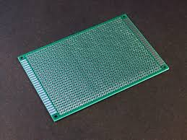

Fig. PCB design

A minimal PCB for a single component, used for [prototyping](https://en.wikipedia.org/wiki/Prototype#Electronics_prototyping), is called a breakout board. The purpose of a breakout board is to "break out" the leads of a component on separate terminals so that manual connections to them can be made easily. Breakout boards are especially used for surface-mount components or any components with fine lead pitch.

Advanced PCBs may contain components embedded in the substrate.

**Characteristics:**

The first PCBs used through-hole technology, mounting electronic components by [leads](https://en.wikipedia.org/wiki/Lead_(electronics)) inserted through holes on one side of the board and soldered onto copper traces on the other side. Boards may be single-sided, with an unplated component side, or more compact double-sided boards, with components soldered on both sides. Horizontal installation of through-hole parts with two axial leads (such as resistors, capacitors, and diodes) is done by bending the leads 90 degrees in the same direction, inserting the part in the board (often bending leads located on the back of the board in opposite directions to improve the part's mechanical strength), soldering the leads, and trimming off the ends. Leads may be [soldered](https://en.wikipedia.org/wiki/Soldering) either manually or by a [wave soldering](https://en.wikipedia.org/wiki/Wave_soldering) machine.

Through-hole manufacture adds to board cost by requiring many holes to be drilled accurately, and it limits the available routing area for [signal traces](https://en.wikipedia.org/wiki/Signal_trace) on layers immediately below the top layer on multi-layer boards, since the holes must pass through all layers to the opposite side. Once surface-mounting came into use, small-sized SMD components were used where possible, with through-hole mounting only of components unsuitably large for surface-mounting due to power requirements or mechanical limitations, or subject to mechanical stress which might damage the PCB (e.g. by lifting the copper off the board surface).

**2.5.RESISTOR:**

A resistor is a passive two-terminal electrical component that implements electrical resistance as a circuit element.



Fig. Resistor

The current through a resistor is in direct proportion to the voltage across the resistor's terminals. This relationship is represented by Ohm's law:

V=IR (4.1)

Where I is the current through the conductor in units of amperes, V is the potential difference measured across the conductor in units of volts, and R is the resistance of the conductor in units of ohms. The ratio of the voltage applied across a resistor's terminals to the intensity of current in the circuit is called its resistance, and this can be assumed to be a constant (independent of the voltage) for ordinary resistors working within their ratings. Resistors are common elements of electrical networks and electronic circuits and are ubiquitous in electronic equipment. Practical resistors can be made of various compounds and films, as well as resistance wire (wire made of a high- resistivity alloy, such as nickel-chrome). Resistors are also implemented within integrated circuits, particularly analog devices, and can also be integrated into hybrid and printed circuits.

**Types of Resistors:**

There are many thousands of different Types of Resistors and are produced in a variety of forms because their particular characteristics and accuracy suit certain areas of application, such as High Stability, High Voltage, High Current etc., or are used as general purpose resistors where their characteristics are less of a problem.

All modern fixed value resistors can be classified into four broad groups,

Carbon Composition Resistor - Made of carbon dust or graphite paste, low wattage values.

Film or Cermet Resistor - Made from conductive metal oxide paste, very low wattage values. Wire-wound Resistor - Metallic bodies for heat sink mounting, very high wattage ratings.

Semiconductor Resistor - High frequency/precision surface mount thin film technology.

Resistance Color Code: In order to identify the nominal resistance and the tolerance of a resistor, manufacturers typically use a color band system known as the resistor color code. The electronic color code is used to indicate the values or ratings of electronic components, usually for resistors.

The power rating is not indicated in the resistor color code and must be determined by experience using the physical size of the resistor as a guide.

For resistors with 5% or 10% tolerance, the color code consists of 4 color bands. For resistors with 1% or 2% tolerance, the color code consists of 5 bands.

Tight tolerance resistors may have three bands for significant figures rather than two, or an additional band indicating temperature coefficient, in units of ppm/K.

**Application:**

Resistors are used with transducers to make sensor subsystems. Transducers are electronic components which convert energy from one form into another, where one of the forms of energy is electrical. Microphones and switches are input transducers. Output transducers include loudspeakers, filament lamps and LEDs.

In other circuits, resistors are used to direct current flow to particular parts of the circuit, or may be used to determine the voltage gain of an amplifier. Resistors are used with capacitors to introduce time delays.

Most electronic circuits require resistors to make them work properly and it is obviously important to find out something about the different types of resistor available, and to be able to choose the correct resistor value, in , , or M , for a particular application.

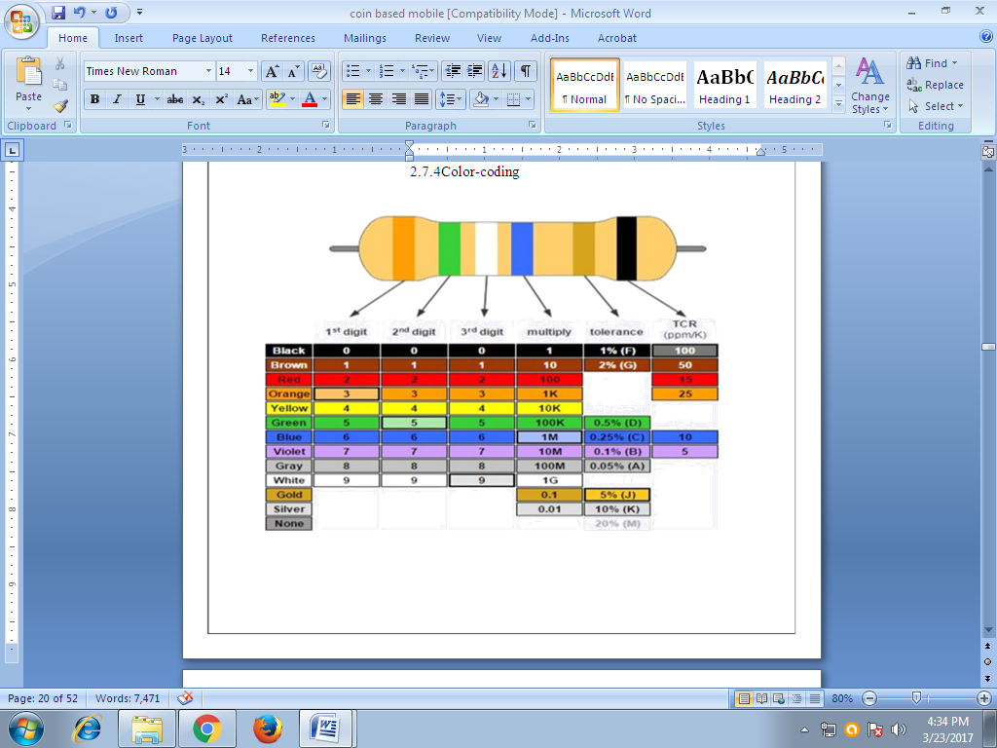

Fig:- Color Coding of Resistor

1. On most resistors, you'll see there are three rainbow-colored bands, then a space, then a fourth band colored brown, red, gold, or silver.
2. Turn the resistor so the three rainbow bands are on the left.
3. The first two of the rainbow bands tell you the first two digits of the resistance. Suppose you have a resistor like the one shown here, with colored bands that are brown, black, and red and a fourth golden band. You can see from the color chart below that brown means 1 and black means 0, so the resistance is going to start with "10". The third band is a decimal multiplier: it tells you how many powers of ten to multiply the first two numbers by (or how many zeros to add on the end, if you prefer to think of it that way). Red means 2, so we multiply the 10 we've got already by 10 × 10 = 100 and get 1000. Our resistor is 1000 ohms.
4. The final band is called the tolerance and it tells you how accurate the resistance value you've just figured out is likely to be. If you have a final band colored gold, it means the resistance is accurate to within plus or minus 5 percent. So while the officially stated resistance is 1000 ohms, in practice, the real resistance is likely to be anywhere between 950 and 1050 ohms.
5. If there are five bands instead of four, the first three bands give the value of the resistance, the fourth band is the decimal multiplier, and the final band is the tolerance. Five-band resistors quoted with three digits and a multiplier, like this, are necessarily more accurate than four-band resistors, so they have a lower tolerance value.

**2.6.LIGHT EMITING DIODE (LED)**

A light-emitting diode (LED) is a semiconductor light source. LEDs are used as indicator lamps in many devices and are increasingly used for other lighting. Appearing as practical electronic components in 1962, early LEDs emitted low intensity red light, but modern versions are available across the visible, ultraviolet, and infrared wavelengths, with very high brightness.



Fig. Light Emitting Diode

When a light-emitting diode is switched on, electrons are able to recombine with holes within the device, releasing energy in the form of photons. This effect is called electroluminescence and the color of the light (corresponding to the energy of the photon) is determined by the energy band gap of the semiconductor. An LED is often small in area (less than 1 mm2), and integrated optical components may be used to shape its radiation pattern. LEDs present many advantages over incandescent light sources including lower energy consumption, longer lifetime, improved physical robustness, smaller size, and faster switching. However, LEDs powerful enough for room lighting are relatively expensive and require more precise current and heat management than compact fluorescent lamp sources of comparable output.

**2.7. Switch:**

In [electrical engineering](https://en.wikipedia.org/wiki/Electrical_engineering), a switch is an [electrical component](https://en.wikipedia.org/wiki/Electrical_component) that can disconnect or connect the conducting path in an [electrical circuit](https://en.wikipedia.org/wiki/Electrical_circuit), interrupting the [electric current](https://en.wikipedia.org/wiki/Electric_current) or diverting it from one conductor to another. The most common type of switch is an electromechanical device consisting of one or more sets of movable [electrical contacts](https://en.wikipedia.org/wiki/Electrical_contact) connected to external circuits. When a pair of contacts is touching current can pass between them, while when the contacts are separated no current can flow.

Switches are made in many different configurations; they may have multiple sets of contacts controlled by the same knob or actuator, and the contacts may operate simultaneously, sequentially, or alternately. A switch may be operated manually, for example, a [light switch](https://en.wikipedia.org/wiki/Light_switch) or a keyboard button, or may function as a [sensing element](https://en.wikipedia.org/wiki/Sensor) to sense the position of a machine part, liquid level, pressure, or temperature, such as a [thermostat](https://en.wikipedia.org/wiki/Thermostat). Many specialized forms exist, such as the [toggle switch](https://en.wikipedia.org/wiki/Toggle_switch), [rotary switch](https://en.wikipedia.org/wiki/Rotary_switch), [mercury switch](https://en.wikipedia.org/wiki/Mercury_switch), [pushbutton switch](https://en.wikipedia.org/w/index.php?title=Pushbutton_switch&action=edit&redlink=1), [reversing switch](https://en.wikipedia.org/w/index.php?title=Reversing_switch&action=edit&redlink=1), [relay](https://en.wikipedia.org/wiki/Relay), and [circuit breaker](https://en.wikipedia.org/wiki/Circuit_breaker). A common use is control of lighting, where multiple switches may be wired into one circuit to allow convenient control of light fixtures. Switches in high-powered circuits must have special construction to prevent destructive arcing when they are opened.

The most familiar form of switch is a manually operated electromechanical device with one or more sets of [electrical contacts](https://en.wikipedia.org/wiki/Electrical_contacts), which are connected to external circuits. Each set of contacts can be in one of two states: either "closed" meaning the contacts are touching and electricity can flow between them, or "open", meaning the contacts are separated and the switch is nonconducting. The mechanism actuating the transition between these two states (open or closed) are usually (there are other types of actions) either an "alternate action" (flip the switch for continuous "on" or "off") or "momentary" (push for "on" and release for "off") type.

A switch may be directly manipulated by a human as a control signal to a system, such as a computer keyboard button, or to control power flow in a circuit, such as a [light switch](https://en.wikipedia.org/wiki/Light_switch). Automatically operated switches can be used to control the motions of machines, for example, to indicate that a garage door has reached its full open position or that a machine tool is in a position to accept another workpiece. Switches may be operated by process variables such as pressure, temperature, flow, current, voltage, and force, acting as [sensors](https://en.wikipedia.org/wiki/Sensor) in a process and used to automatically control a system. For example, a [thermostat](https://en.wikipedia.org/wiki/Thermostat) is a temperature-operated switch used to control a heating process. A switch that is operated by another electrical circuit is called a [relay](https://en.wikipedia.org/wiki/Relay). Large switches may be remotely operated by a motor drive mechanism. Some switches are used to isolate electric power from a system, providing a visible point of isolation that can be padlocked if necessary to prevent accidental operation of a machine during maintenance, or to prevent electric shock.

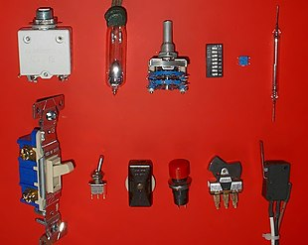

An ideal switch would have no voltage drop when closed, and would have no limits on voltage or current rating. It would have zero [rise time](https://en.wikipedia.org/wiki/Rise_time) and [fall time](https://en.wikipedia.org/wiki/Fall_time) during state changes, and would change state without "bouncing" between on and off positions.

Practical switches fall short of this ideal; as the result of roughness and oxide films, they exhibit [contact resistance](https://en.wikipedia.org/wiki/Contact_resistance), limits on the current and voltage they can handle, finite switching time, etc. The ideal switch is often used in circuit analysis as it greatly simplifies the system of equations to be solved, but this can lead to a less accurate solution. Theoretical treatment of the effects of non-ideal properties is required in the design of large networks of switches, as for example used in telephone exchanges.

# 2.8.Potentiometer:

The Potentiometer is an electric instrument that used to measure the [EMF (electro motive force)](https://www.elprocus.com/emf-detector-circuit-working-types-and-its-applications/) of a given cell, the internal resistance of a cell. And also it is used to compare EMFs of different cells. It can also use as a [variable resistor](https://www.elprocus.com/types-of-variable-resistors-its-working-and-applications/) in most of the applications. These potentiometers are used in huge quantities in the manufacture of electronics equipment that provides a way of adjusting [electronic circuits](https://www.elprocus.com/build-your-own-electronic-circuits-for-simple-applications/) so that the correct outputs are obtained. Although their most obvious use must be for volume controls on radios and other electronic equipment used for audio.

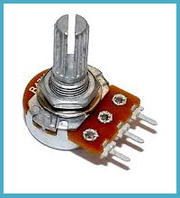

Why is Potentiometer chosen over Voltmeter to measure the potential (EMF) of a cell? When we use Voltmeter, current flows through the circuit and because of the internal resistance of the cell, always terminal potential will be less than the actual cell potential. In this circuit, when the potential difference is balanced (using a Galvanometer null detection), no current flows in the circuit, so the terminal potential will be equal to the actual cell potential. So we can understand that the Voltmeter measures the terminal potential of a cell, but this measures actual cell potential. The schematic symbols of this is shown below.

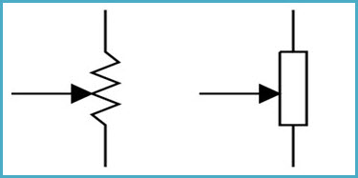

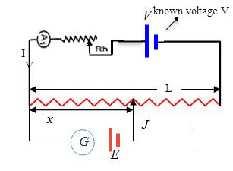

Fig. Construction of Potentiometer

The basic working principle of this is based on the fact that the fall of the potential across any portion of the wire is directly proportional to the length of the wire, provided wire has uniform cross-sectional area and the constant current flowing through it.“When there is no potential difference between any two nodes there is electric current will flow”.

Now the potentiometer wire is actually a wire with high resistivity (ῥ) with uniform cross-sectional area A. Thus, throughout the wire, it has uniform resistance. Now this potentiometer terminal connected to the cell of high EMF V (neglecting its internal resistance) called driver cell or the voltage source. Let the current through the potentiometer is I and R is the total resistance of the potentiometer.

Then by Ohms law V=IR

**Types of Potentiometers**

A potentiometer is also commonly known as pot. These potentiometers have three terminal connections. One terminal connected to a sliding contact called wiper and the other two terminals are connected to a fixed resistance track. The wiper can be moved along the resistive track either by use of a linear sliding control or a rotary “wiper” contact. Both rotary and linear controls have the same basic operation.

The most common form of the potentiometer is the single turn rotary potentiometer. This type of potentiometer is often used in audio volume control (logarithmic taper) as well as many other applications. Different materials are used to construct potentiometers, including carbon composition, cermet, conductive plastic, and the metal film.

#### Rotary Potentiometers

These are the most common type of potentiometers, where the wiper moves along a circular path.

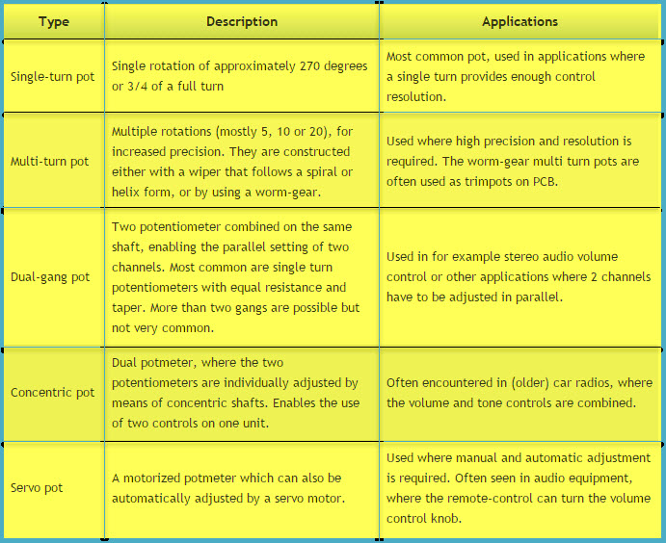

Rotary Potentiometers

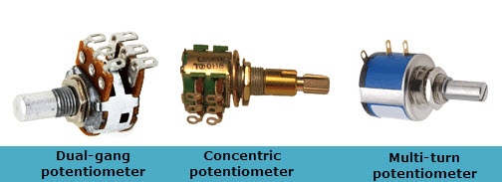

#### Linear Potentiometers

In these types of Potentiometers the wiper moves along a linear path. Also known as slide pot, slider, or fader.

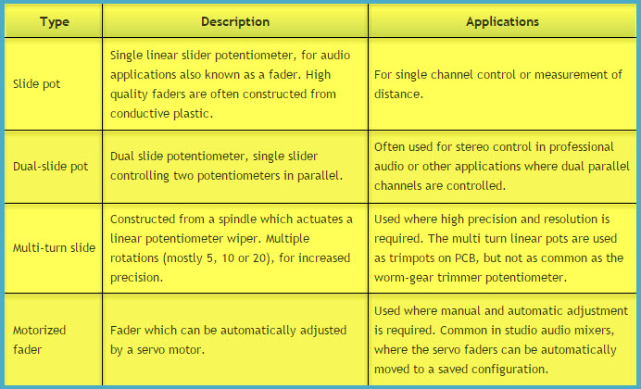

Linear Potentiometers

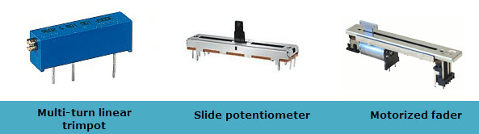

### Applications of Potentiometers

#### Potentiometer as a Voltage Divider

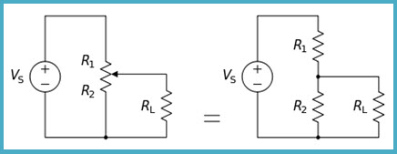

**Voltage Divider**

The potentiometer can be worked as [a voltage divider](https://www.elprocus.com/voltage-divider-rule-with-examples/) to obtain a manual adjustable output voltage at the slider from a fixed input voltage applied across the two ends of the potentiometer. Now the load voltage across RL can be measured as

VL= R2RL. VS/(R1RL+R2RL+R1R2)

2.9. **LIQUID CRYSTAL DISPLAY (LCD):**

****

**Figure Liquid Crystal Display**

· Vcc, at pin 16 controls the background contrast.

· Vcc, at pin 2 controls the display contrast.

· Pin 7 - 14 gets input data.

· Pin 1 and pin 3 controls the brightness of the display.

· Pin 5, gets a read/write signal.

· Pin 6, enable signal.

· Pin 4, data register select.



**LCD Pins**



**Table Pin Assignment**

**Interfacing Example - 16 Character x 2 Line LCD**

**Description:**

This is the first interfacing example for the Parallel Port. We will start with something simple. This example doesn't use the Bi-directional feature found on newer ports, thus it should work with most, if no all Parallel Ports. It however doesn't show the use of the Status Port as an input. So what are we interfacing? A 16 Character x 2 Line LCD Module to the Parallel Port. These LCD Modules are very common these days, and are quite simple to work with, as all the logic required running them is on board.

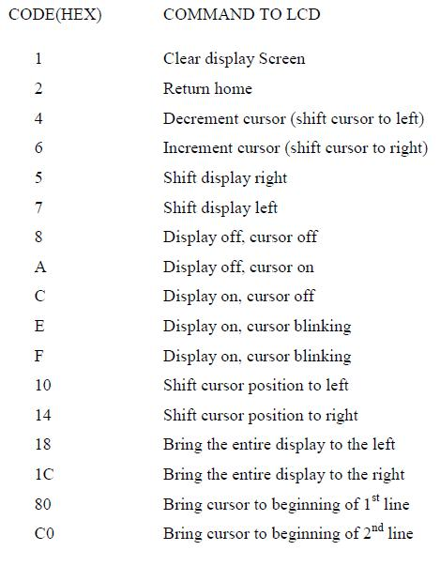

**Schematic:**



**Circuit Description:**

Above is the quite simple schematic. The LCD panel's Enable and Register Select is connected to the Control Port. The Control Port is an open collector / open drain output. While most Parallel Ports have internal pull-up resistors, there are a few which don't. Therefore by incorporating the two 10K external pull up resistors, the circuit is more portable for a wider range of computers, some of which may have no internal pull up resistors. We make no effort to place the Data bus into reverse direction. Therefore we hard wire the R/W line of the LCD panel, into write mode. This will cause no bus conflicts on the data lines. As a result we cannot read back the LCD's internal Busy Flag which tells us if the LCD has accepted and finished processing the last instruction. This problem is overcome by inserting known delays into our program.

The 10k Potentiometer controls the contrast of the LCD panel. Nothing fancy here. As with all the examples, I've left the power supply out. You can use a bench power supply set to 5v or use a onboard +5 regulator. Remember a few de-coupling capacitors, especially if you have trouble with the circuit working properly. The 2 line x 16 character LCD modules are

available from a wide range of manufacturers and should all be compatible with the HD44780. The one I used to test this circuit was a Power trip PC- 1602F and an old Philips LTN211F-10 which was extracted from a Poker Machine! The diagram to the right shows the pin numbers for these devices. When viewed from the front, the left pin is pin 14 and the right pin is pin

The LCD panel requires a few instructions to be sent, to order to turn on the display and initialize it. This is what the first for loop does. These instructions must be sent to the LCD's Instruction Register which is controlled by the Register Select (Pin 4). When pin 4 is low the instruction register is selected, thus when high the data register must be selected. We connect this to the Parallel Port's Select Printer line which happens to be hardware inverted. Therefore if we write a '1' to bit 3 of the Control Register the Select Printer line goes low. We want to first send instructions to the LCD module. Therefore the Register Select line must be low. As it is hardware inverted, we will want to set bit 3 of the Control Register to '1'. However we don't want to upset any other bits on the Control Port. We achieve this by reading the Control Port and Oaring 0x80 to it. E.g. out port (CONTROL, in port b (CONTROL) | 0x08);

this will only set bit 3. After we place a data byte on the data lines, we must then signal to the

LCD module to read the data. This is done using the Enable line. Data is clocked into the LCD module on the high to low transition. The Strobe is hardware inverted, thus by setting bit 0 of the Control Register we get a high to low transition on the Strobe line. We then wait for a delay, and return the line to a high state ready for the next byte. After we initialize the LCD Module, we want to send text to it. Characters are sent to the LCD's Data Port, thus we want to clear bit 3. Once again we must only change the one bit, thus we use out port b (CONTROL, in port b(CONTROL) & 0xF7);. Then we set up another for loop to read a byte

from the string and send it to the LCD panel. This is repeated for the length of the string. The delays should be suitable for most machines. If the LCD panel is not initializing properly, you can try increasing the delays. Likewise if the panel is skipping characters, e.g. Test, 2. On the other hand, if the LCD module is repeating characters e.g. testing then you may have a faulting Enable connection. Check your Enable to Strobe connection.

## 2.10. GPS

GPS stands for Global Positioning System by which anyone can always obtain the position information anywhere in the world.

## 2. Basic structure of GPS

### Three-block configuration

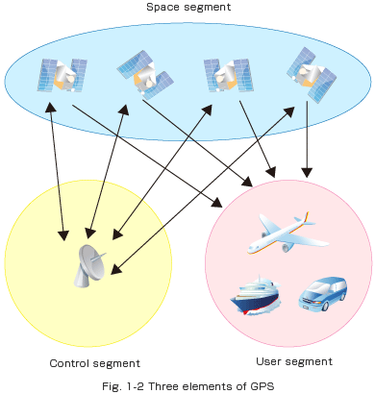

GPS consists of the following three segments.

Space segment (GPS satellites)

A number of GPS satellites are deployed on six orbits around the earth at the altitude of approximately 20,000 km (four GPS satellites per one orbit), and move around the earth at 12-hour-intervals.

Control segment (Ground control stations)

Ground control stations play roles of monitoring, controlling and maintaining satellite orbit to make sure that the deviation of the satellites from the orbit as well as GPS timing are within the tolerance level.

User segment (GPS receivers)

User segment (GPS receivers)

### GPS positioning

Firstly, the signal of time is sent from a GPS satellite at a given point. Subsequently, the time difference between GPS time and the point of time clock which GPS receiver receives the time signal will be calculated to generate the distance from the receiver to the satellite. The same process will be done with three other available satellites. It is possible to calculate the position of the GPS receiver from distance from the GPS receiver to three satellites. However, the position generated by means of this method is not accurate, for there is an error in calculated distance between satellites and a GPS receiver, which arises from a time error on the clock incorporated into a GPS receiver. For a satellite, an atomic clock is incorporated to generate on-the-spot time information, but the time generated by clocks incorporated into GPS receivers is not as precise as the time generated by atomic clocks on satellites. Here, the fourth satellite comes to play its role: the distance from the fourth satellite to the receiver can be used to compute the position in relations to the position data generated by distance between three satellites and the receiver, hence reducing the margin of error in position accuracy.

The Fig 1-3 below illustrates an example of positioning by two dimensions (position acquisition by using two given points). We can compute where we are at by calculating distance from two given points, and the GPS is the system that can be illustrated by multiplying given points and replacing them with GPS satellites on this figure.

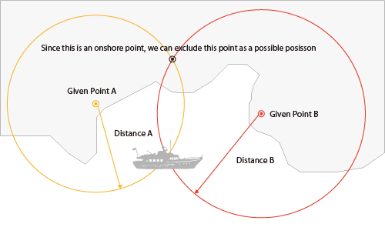

### GPS signals

GPS satellites broadcast beams in two carrier frequencies; L1 (1,575.42 MHz) and L2 (1,227.60 MHz). Beams that can be accessible to the general public are encoded in C/A (Coarse/Acquisition) code, and the beams that can be used only by the US military force are encoded in P (Precise) code. C/A code consists of identification codes of each satellite and is broadcast together with navigation messages. The data of the orbit of each satellite is called the ephemeris\*, and the data of orbit of all satellite is called the almanac\*\*. The navigation messages are broadcast at a rate of 50 bits per second. Utilizing this collection of data, GPS receiver calculates distance between satellites and the receiver in order to generate position data. In the Fig 1-4, the details of C/A code is described, and in the Fig 1-5, navigation messages are described.

\*The ephemeris provides the precise orbit for the satellite itself, which can be used to generate precise location of the satellite, necessary information for calculating position information. It is the indigenous data that is used only by each of the GPS satellites with specific identification number.

\*\*The almanac can be regarded as simplified ephemeris data and contains coarse orbit and status information for all satellites in the network. It is used to locate available satellites in order a GPS receiver to generate current position and time. It takes 12.5 minutes to receive all the almanac data.

What is C/A code?

L1 signal from the GPS satellites is phase-modulated in C/A code, which is the pseudorandom code. The pseudorandom code is also called pseudorandom noise code, which is known as a Gold code. As the Fig. 1-4 illustrates, C/A code is a sequence of digital signals “1” and “0”. In GPS, 1,023 consecutive patterns comprise a sequence, and subsequently, this sequence will continually repeat one after another.

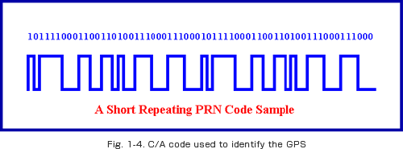

Navigation message

Navigation message consists of 25 frames, each of which includes 5 subframes of 300 bits each. The data length of 1 bit is 20 ms, and thus, the length of each subframe is 6 seconds, and each frame is a grouping of 1,500 bits of information with the frame length of 30 seconds. Since navigation message consists of 25 frames, this would add up to the message length of 12.5 minutes (30 seconds x 25=12.5 minutes). The GPS receiver requires 12.5 minutes to receive all the necessary set of data, necessary condition for positioning, when initial power activation takes place. The GPS receiver is capable of storing this set of data gained in the past internal backup battery, and it reads out the set of data when power reactivation takes place, hence instantaneously starting to receive GPS position.

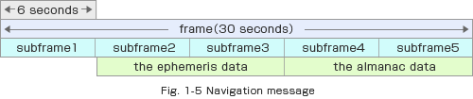

## 3. Positioning accuracy

### Factors that trigger GPS position errors

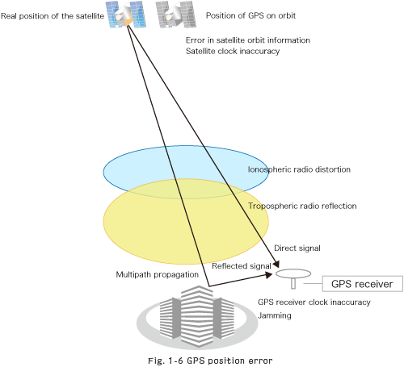

Ionosphere

The ionosphere is a portion of the upper atmosphere, between the thermosphere and the exosphere. When GPS signals pass through this layer, the propagation velocity of the GPS signal goes slower, hence causing propagation error.

Troposphere

The troposphere is the lowest portion of Earth's atmosphere. Radio reflections caused by dry atmosphere and water vapor within provoke GPS position error.

Multipath propagation

GPS signal is not immune to reflection when it hits on the ground, structures and many others. This phenomenon is called multipath propagation, one of the causes of GPS position errors.

### DOP (Dilution Of Precision)

DOP is a value that shows the degree of degradation of the GPS positioning accuracy. The smaller the value is, the higher the positioning accuracy is. This value depends upon the positions of the GPS satellites tracked for positioning. If the tracked satellites spread evenly over the earth, the positioning accuracy would become higher, and if the positions of tracked satellites are disproportionate, the positioning accuracy would become lower.

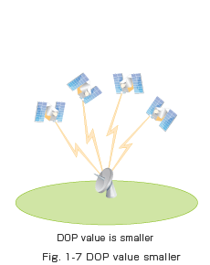 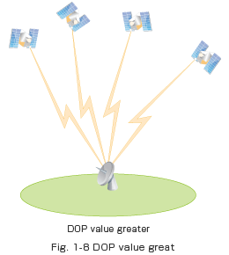

### Signal strength

State of reception of GPS depends upon the strength of GPS signals. The greater the signal strength is, the more stable the reception status is. Whereas the reception status would become unstable when the GPS signal became weaker, due to obstacles or noise sources in the vicinity of a GPS receiver.

* 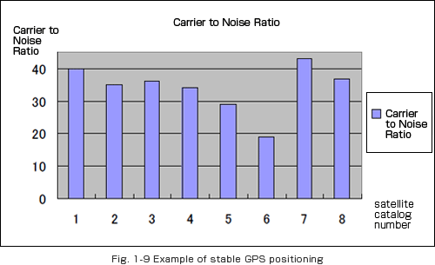
* 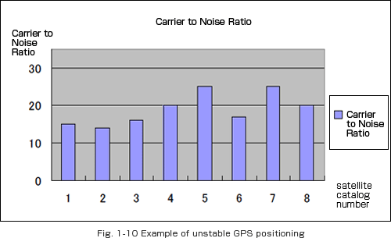

### Number of satellites tracked for positioning

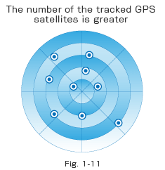 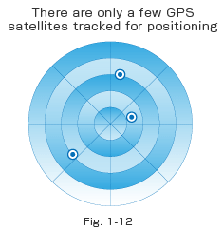



State of reception of GPS depends upon the number of satellites tracked for positioning.

If the number of the tracked satellites is great, GPS positioning becomes greater, but if there were a fewer satellites tracked for positioning, it would be difficult to generate GPS position. The Fig. 1-11 illustrates the occasion where the GPS receiver tracks a greater number of satellites for positioning. The Fig. 1-12 illustrates the occasion where the GPS receiver tracks only a few number of satellites for positioning.

GPS receivers are generally used in smartphones, fleet management system, military etc. for tracking or finding location.

**G**lobal **P**ositioning **S**ystem (GPS) is a satellite-based system that uses satellites and ground stations to measure and compute its position on Earth.

GPS is also known as Navigation System with Time and Ranging (NAVSTAR) GPS.

GPS receiver needs to receive data from at least 4 satellites for accuracy purpose. GPS receiver does not transmit any information to the satellites.

This GPS receiver is used in many applications like smartphones, Cabs, Fleet management etc.

# How GPS Works



**GIF Source: Wikipedia**

GPS receiver uses a constellation of satellites and ground stations to calculate accurate location wherever it is located.

These GPS satellites transmit information signal over radio frequency (1.1 to 1.5 GHz) to the receiver. With the help of this received information, a ground station or GPS module can compute its position and time.

# How GPS Receiver Calculates its Position and Time

GPS receiver receives information signals from GPS satellites and calculates its distance from satellites. This is done by measuring the time required for the signal to travel from satellite to the receiver.

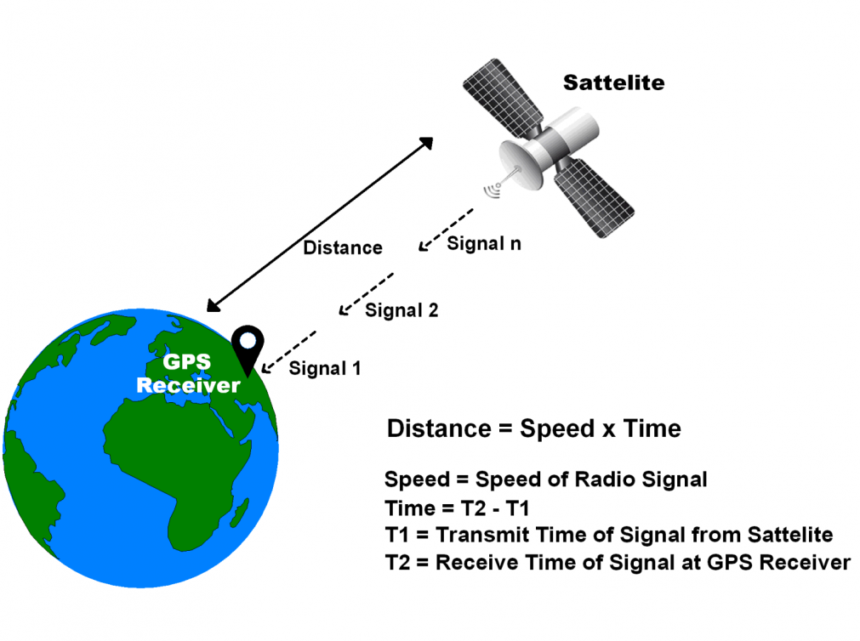

**GPS Distance Calculation**



Where,

Speed = Speed of Radio signal which is approximately equal to the speed of light i.e.

Time = Time required for a signal to travel from the satellite to the receiver.

By subtracting the sent time from the received time, we can determine the travel time.

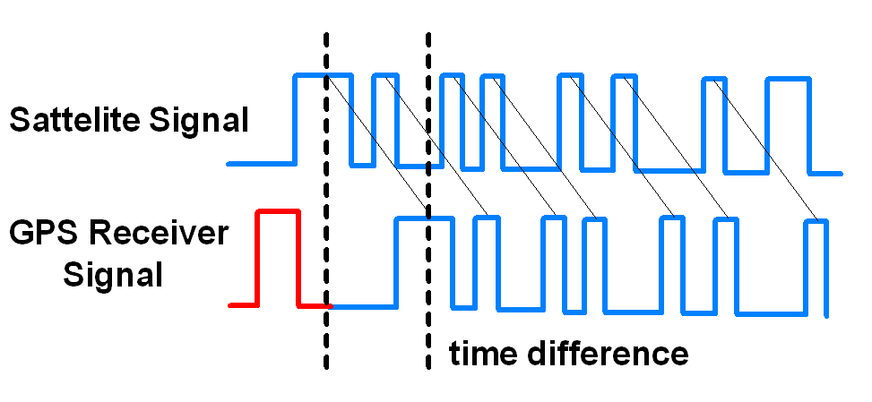

**GPS Signal Time Difference**

To determine distance, both the satellite and GPS receiver generate the same pseudocode signal at the same time.

The satellite transmits the pseudocode; which is received by the GPS receiver.

These two signals are compared and the difference between the signals is the travel time.

Now, if the receiver knows the distance from 3 or more satellites and their location (which is sent by the satellites), then it can calculate its location by using [Trilateration](http://electronics.howstuffworks.com/gadgets/travel/gps1.htm) method.

# GPS Module

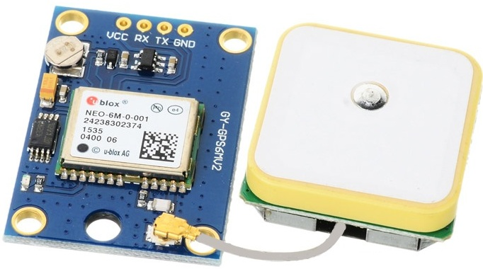

**GPS Receiver**

GPS receiver module gives output in standard (National Marine Electronics Association) NMEA string format. It provides output serially on Tx pin with default 9600 Baud rate.

This NMEA string output from GPS receiver contains different parameters separated by commas like longitude, latitude, altitude, time etc. Each string starts with ‘$’ and ends with carriage return/line feed sequence.

**E.g.**

$GPGGA,184237.000,1829.9639,N,07347.6174,E,1,05,2.1,607.1,M,-64.7,M,,0000\*7D

$GPGSA,A,3,15,25,18,26,12,,,,,,,,5.3,2.1,4.8\*36

$GPGSV,3,1,11,15,47,133,46,25,44,226,45,18,37,238,45,26,34,087,40\*72

$GPGSV,3,2,11,12,27,184,45,24,02,164,26,29,58,349,,05,26,034,\*7F

$GPGSV,3,3,11,21,25,303,,02,11,071,,22,01,228,\*40

$GPRMC,184237.000,A,1829.9639,N,07347.6174,E,0.05,180.19,230514,,,A\*64

**Pin Description**

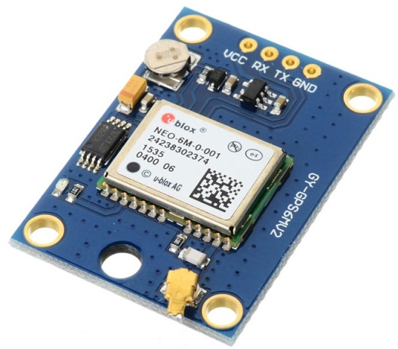

**GPS Receiver Module**

**VCC:** Power Supply 3.3 – 6 V

**GND:**Ground

**TX:**Transmit data serially which gives information about location, time etc.

**RX:**Receive Data serially. It is required when we want to configure GPS module.

# Check GPS module

Before Interfacing GPS module with PIC18F4550 microcontroller, we can check the output of GPS module. From that string, we can extract information like longitude, latitude, time which is helpful to find location and timing information.

To do this, connect this GPS module to the PC via USB to Serial converter or DB9 connector. Also, it is necessary to keep antenna of GPS module on proper location.

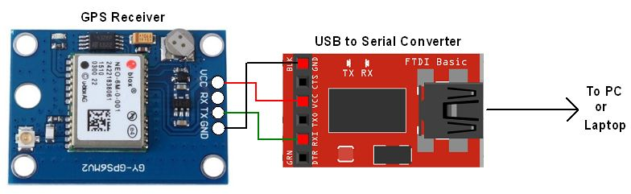

**GPS Serial Interface**

1. Now open any serial terminal e.g. Realterm, Hyper terminal, Putty etc. on PC/laptop.
2. Open the PORT with 9600 baud rate.
3. The terminal will show data coming from GPS receiver module.

**2.11. GSM MODULE SIM 900L**

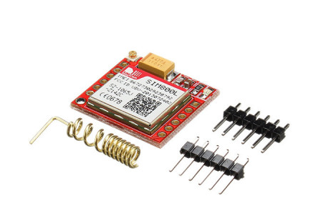

Sim800L Module is low cost, low form factor GSM module based on Simcoms SIM800L chipset. Sim800L module supports quad-band GSM and GPRS network.

This breakout board is perfect for application where size and cost is a constraint. Sim800l gsm module also supports quad band which means that it can work anywhere in the world. This low cost module is perfect for launching your next IoT project. Using this module you can almost make your own cellphone.

Using this module you can:-

* Send Text Messages (SMS)
* Make or receive Phone calls
* Connect to Internet via GPRS
* TCP/IP

The main drawback of this module is works on 3.7 to 4.2 volts so you cannot power it directly through Arduino or Raspberry Pi. Moreover the sim800L GSM and GPRS module requires upto 2 ampere current so accordingly design your power supply. You can use a 3.7 volt lipo battery to directly power the GSM module.

You can communicate with SIM800l module via UART port, supports command including 3GPP TS 27.007, 27.005 and SIM COM enhanced AT Commands.

Features of SIM800L GSM Module:-

* Quad-band 850/900/1800/1900MHz - connect onto any global GSM network with any 2G SIM (in the USA, T-Mobile is suggested).
* Make and receive voice calls using a headset or an external 8Ω speaker and electret microphone.
* PWM/Buzzer vibration motor control
* AT command interface with "auto baud" detection
* Send and receive SMS messages.
* Send and receive GPRS data (TCP/IP, HTTP, etc.).
* Scan and receive FM radio broadcasts.
* Lead out buzzer and vibration motor control port.
* AT command interface with "auto baud" detection.
* Onboard IPEX socket that can be connected to external antenna.
* Breakouts for external 8W speaker and electret mic if you don't want to use a headphone
* Level shifting circuitry so you can run it with 2.8V to 5V logic.
* Vibrational motor (buzzer) driver so you can have noiseless notifications
* uFL or SMA connections for external antenna
* Indicator LEDs for power and network connectivity
* Standard SIM slides into the back

# 2.12. Buzzer

A buzzer or beeper is an [audio](https://en.wikipedia.org/wiki/Sound) signaling device, which may be [mechanical](https://en.wikipedia.org/wiki/Machine), [electromechanical](https://en.wikipedia.org/wiki/Electromechanics), or [piezoelectric](https://en.wikipedia.org/wiki/Piezoelectricity) (piezo for short). Typical uses of buzzers and beepers include [alarm devices](https://en.wikipedia.org/wiki/Alarm_devices), [timers](https://en.wikipedia.org/wiki/Timer), and confirmation of user input such as a mouse click or keystroke.

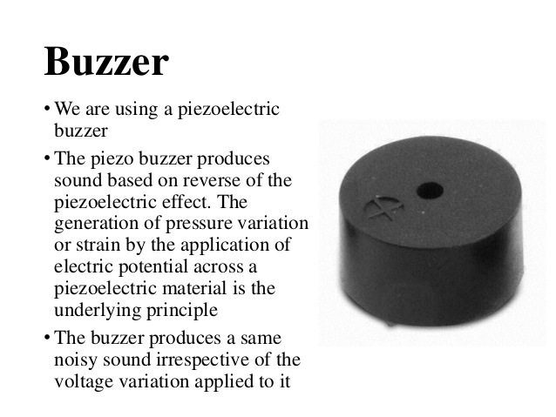

**2.13.** . Pulse sensor

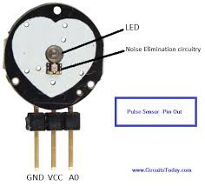

fig 3

* Connect the Pulse Sensor with the Arduino. The Pulse sensor has three pins. Connect 5V and the ground pin of the pulse sensor to the 5V and the ground of the Arduino and the signal pin to the A0 of Arduino
* Pulse Sensor is a well-designed plug-and-play heart-rate sensor for Arduino. The basic heartbeat sensor consists of a light-emitting diode and a detector like a light detecting resistor or a photodiode. Some of the light is absorbed by the blood and the transmitted or the reflected light is received by the light detector. The amount of light absorbed depends on the blood volume in that tissue.

**2.14..LM-35 temperature sensor**

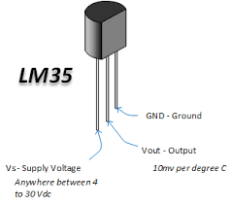

fig 4

The LM35 is one kind of commonly used temperature sensor that can be used to measure temperature with an electrical o/p comparative to the temperature (in °C). It can measure temperature more correctly compare with a thermistor. This sensor generates a high output voltage than thermocouples and may not need that the output voltage is amplified. The LM35 has an output voltage that is proportional to the Celsius temperature. The scale factor is .01V/°C.

**CHAPTER-III**

**3.1. Software:**

The C computer programming language was used to create a set of instructions for the bidirectional visitor counter to run through a C compiler on a computer in the first place. The instruction set code is converted to into machine language (Hex file) for it to b readable to the microcontroller. The full instruction set code for the bidirectional visitor counter system is given in Appendix.

**Code:**

The software used for coding programes for the cube is Arduino 1.0.2/1.5.2 and the matlab programs require arduino support package which is downloaded from arduino website. With Matlab GUI interface we created buttons which when clicked trigger some code which plots a graph and controls the arduino.

#include <LiquidCrystal.h>

// Variables

int pulsePin = 0; // Pulse Sensor purple wire connected to analog pin 0

int blinkPin = 13; // pin to blink led at each beat

int fadePin = 8; // pin to do fancy classy fading blink at each beat

int fadeRate = 0; // used to fade LED on with PWM on fadePin

const int sensor=A1; // Assigning analog pin A1 to variable ‘sensor’

float tempc; //variable to store temperature in degree Celsius

float tempf; //variable to store temperature in Fahreinheit

float vout; //temporary variable to hold sensor reading

LiquidCrystal lcd(13,12,6,5,4,3);// Volatile Variables, used in the interrupt service routine!

volatile int BPM; // int that holds raw Analog in 0. updated every 2mS

volatile int Signal; // holds the incoming raw data

volatile int IBI = 600; // int that holds the time interval between beats! Mustbe seeded!

volatile boolean Pulse = false; // “True” when User’s live heartbeat is detected. “False” when not a “live beat”.

volatile boolean QS = false; // becomes true when Arduoino finds a beat.

// Regards Serial OutPut — Set This Up to your needs

static boolean serialVisual = true; // Set to ‘false’ by Default. Re-set to ‘true’ to see Arduino Serial Monitor ASCII Visual Pulse

volatile int rate[10]; // array to hold last ten IBI values

volatile unsigned long sampleCounter = 0; // used to determine pulse timing

volatile unsigned long lastBeatTime = 0; // used to find IBI

volatile int P = 250; // used to find peak in pulse wave, seeded

volatile int T = 250; // used to find trough in pulse wave, seeded

volatile int thresh = 250; // used to find instant moment of heart beat, seeded

volatile int amp = 50; // used to hold amplitude of pulse waveform, seeded

volatile boolean firstBeat = true; // used to seed rate array so we startup with reasonable BPM

volatile boolean secondBeat = false; // used to seed rate array so we startup with reasonable BPM

void setup()

{

pinMode(blinkPin,OUTPUT); // pin that will blink to your heartbeat!

pinMode(fadePin,OUTPUT); // pin that will fade to your heartbeat!

Serial.begin(115200); // we agree to talk fast!

interruptSetup(); // sets up to read Pulse Sensor signal every 2mS

// IF YOU ARE POWERING The Pulse Sensor AT VOLTAGE LESS THAN THE BOARD VOLTAGE,

// UN-COMMENT THE NEXT LINE AND APPLY THAT VOLTAGE TO THE A-REF PIN

// analogReference(EXTERNAL);

pinMode(sensor,INPUT); // Configuring pin A1 as input

Serial.begin(9600);

}

// Where the Magic Happens

void loop()

{

serialOutput();

if (QS == true) // A Heartbeat Was Found

{

// BPM and IBI have been Determined

// Quantified Self “QS” true when arduino finds a heartbeat

fadeRate = 255; // Makes the LED Fade Effect Happen, Set ‘fadeRate’ Variable to 255 to fade LED with pulse

serialOutputWhenBeatHappens(); // A Beat Happened, Output that to serial.

QS = false; // reset the Quantified Self flag for next time

vout=analogRead(sensor);

vout=(vout\*500)/1023;

tempc=vout; // Storing value in Degree Celsius

tempf=(vout\*1.8)+32; // Converting to Fahrenheit

Serial.print(“in DegreeC=”);

Serial.print(“\t”);

Serial.print(tempc);

Serial.println();

Serial.print(“in Fahrenheit=”);

Serial.print(“\t”);

Serial.print(tempf);

Serial.println();

lcd.print(“temp in c:”);

lcd.print(tempc);

delay(2000); //Delay of 1 second for ease of viewing

}

ledFadeToBeat(); // Makes the LED Fade Effect Happen

delay(20); // take a break

}

void ledFadeToBeat()

{

fadeRate -= 15; // set LED fade value

fadeRate = constrain(fadeRate,0,255); // keep LED fade value from going into negative numbers!

analogWrite(fadePin,fadeRate); // fade LED

}

void interruptSetup()

{

// Initializes Timer2 to throw an interrupt every 2mS.

TCCR2A = 0x02; // DISABLE PWM ON DIGITAL PINS 3 AND 11, AND GO INTO CTC MODE

TCCR2B = 0x06; // DON’T FORCE COMPARE, 256 PRESCALER

OCR2A = 0X7C; // SET THE TOP OF THE COUNT TO 124 FOR 500Hz SAMPLE RATE

TIMSK2 = 0x02; // ENABLE INTERRUPT ON MATCH BETWEEN TIMER2 AND OCR2A

sei(); // MAKE SURE GLOBAL INTERRUPTS ARE ENABLED

}

void serialOutput()

{ // Decide How To Output Serial.

if (serialVisual == true)

{

arduinoSerialMonitorVisual(‘-’, Signal); // goes to function that makes Serial Monitor Visualizer

}

else{

sendDataToSerial(‘S’, Signal); // goes to sendDataToSerial function

}

}

void serialOutputWhenBeatHappens()

{

if (serialVisual == true) // Code to Make the Serial Monitor Visualizer Work

{

Serial.print(“\*\*\* Heart-Beat Happened \*\*\* “); //ASCII Art Madness

Serial.print(“BPM: “);

Serial.println(BPM);

lcd.clear();

lcd.print(“BPM: “);

lcd.print(BPM);}

else

{

sendDataToSerial(‘B’,BPM); // send heart rate with a ‘B’ prefix

sendDataToSerial(‘Q’,IBI); // send time between beats with a ‘Q’ prefix

}

}

void arduinoSerialMonitorVisual(char symbol, int data )

{

const int sensorMin = 0; // sensor minimum, discovered through experiment

const int sensorMax = 1024; // sensor maximum, discovered through experiment

int sensorReading = data; // map the sensor range to a range of 12 options:

int range = map(sensorReading, sensorMin, sensorMax, 0, 11);

// do something different depending on the

// range value:

switch (range)

{case 0:

Serial.println(“”); /////ASCII Art Madnessbreak;

case 1:

Serial.println(“ — -”);

break;

case 2:

Serial.println(“ — — — “);

break;case 3:

Serial.println(“ — — — — -”);

break;

case 4:Serial.println(“ — — — — — — “);

break;

case 5:Serial.println(“ — — — — — — — |-”);

break;

case 6:

Serial.println(“ — — — — — — — | — -”);

break;

case 7:Serial.println(“ — — — — — — — | — — — -”);

break;

case 8:

Serial.println(“ — — — — — — — | — — — — — “);

break;

case 9:

Serial.println(“ — — — — — — — | — — — — — — — — “);

break;

case 10:

Serial.println(“ — — — — — — — | — — — — — — — — — -”);

break;

case 11:

Serial.println(“ — — — — — — — | — — — — — — — — — — — -”);

break;

}

}

void sendDataToSerial(char symbol, int data )

{

Serial.print(symbol);

Serial.println(data);

}

ISR(TIMER2\_COMPA\_vect) //triggered when Timer2 counts to 124

{

cli(); // disable interrupts while we do this

Signal = analogRead(pulsePin); // read the Pulse Sensor

sampleCounter += 2; // keep track of the time in mS with this variable

int N = sampleCounter — lastBeatTime; // monitor the time since the last beat to avoid noise

// find the peak and trough of the pulse wave

if(Signal < thresh && N > (IBI/5)\*3) // avoid dichrotic noise by waiting 3/5 of last IBI

{

if (Signal < T) // T is the trough

{

T = Signal; // keep track of lowest point in pulse wave

}}

if(Signal > thresh && Signal > P)

{ // thresh condition helps avoid noise

P = Signal; // P is the peak

} // keep track of highest point in pulse wave

// NOW IT’S TIME TO LOOK FOR THE HEART BEAT

// signal surges up in value every time there is a pulse

if (N > 250)

{ // avoid high frequency noise

if ( (Signal > thresh) && (Pulse == false) && (N > (IBI/5)\*3) )

{

Pulse = true; // set the Pulse flag when we think there is a pulse

digitalWrite(blinkPin,HIGH); // turn on pin 13 LED

IBI = sampleCounter — lastBeatTime; // measure time between beats in mS

lastBeatTime = sampleCounter; // keep track of time for next pulse

if(secondBeat)

{ // if this is the second beat, if secondBeat == TRUE

secondBeat = false; // clear secondBeat flag

for(int i=0; i<=9; i++) // seed the running total to get a realisitic BPM at startup

{

rate[i] = IBI;

}

}

if(firstBeat) // if it’s the first time we found a beat, if firstBeat == TRUE

{

firstBeat = false; // clear firstBeat flagsecondBeat = true; // set the second beat flag

sei(); // enable interrupts again

return; // IBI value is unreliable so discard it

}

// keep a running total of the last 10 IBI values

word runningTotal = 0; // clear the runningTotal variable

for(int i=0; i<=8; i++)

{ // shift data in the rate array

rate[i] = rate[i+1]; // and drop the oldest IBI value

runningTotal += rate[i]; // add up the 9 oldest IBI values

}

rate[9] = IBI; // add the latest IBI to the rate array

runningTotal += rate[9]; // add the latest IBI to runningTotal

runningTotal /= 10; // average the last 10 IBI values

BPM = 60000/runningTotal; // how many beats can fit into a minute? that’s BPM!

QS = true; // set Quantified Self flag

// QS FLAG IS NOT CLEARED INSIDE THIS ISR

}

}

if (Signal < thresh && Pulse == true)

{ // when the values are going down, the beat is over

digitalWrite(blinkPin,LOW); // turn off pin 13 LED

Pulse = false; // reset the Pulse flag so we can do it again

amp = P — T; // get amplitude of the pulse wave

thresh = amp/2 + T; // set thresh at 50% of the amplitude

P = thresh; // reset these for next time

T = thresh;

}

if (N > 2500)

{ // if 2.5 seconds go by without a beat

thresh = 250; // set thresh default

P = 250; // set P default

T = 250; // set T default

lastBeatTime = sampleCounter; // bring the lastBeatTime up to date

firstBeat = true; // set these to avoid noise

secondBeat = false; // when we get the heartbeat back

}

sei(); // enable interrupts when youre done!

}// end isr

**CHAPTER-IV**

**4.Testing:**

### 4.1.System Testing

The purpose of testing is to discover errors. Testing is the process of trying to discover every conceivable fault or weakness in a work product. It provides a way to check the functionality of components, sub assemblies, assemblies and/or a finished product It is the process of exercising software with the intent of ensuring that the

Software system meets its requirements and user expectations and does not fail in an unacceptable manner. There are various types of test. Each test type addresses a specific testing requirement.

**Types of Tests:**

**Unit testing**

Unit testing involves the design of test cases that validate that the internal program logic is functioning properly, and that program inputs produce valid outputs. All decision branches and internal code flow should be validated. It is the testing of individual software units of the application .it is done after the completion of an individual unit before integration. This is a structural testing, that relies on knowledge of its construction and is invasive. Unit tests perform basic tests at component level and test a specific business process, application, and/or system configuration. Unit tests ensure that each unique path of a business process performs accurately to the documented specifications and contains clearly defined inputs and expected results.

**Integration testing**

Integration tests are designed to test integrated software components to determine if they actually run as one program. Testing is event driven and is more concerned with the basic outcome of screens or fields. Integration tests demonstrate that although the components were individually satisfaction, as shown by successfully unit testing, the combination of components is correct and consistent. Integration testing is specifically aimed at exposing the problems that arise from the combination of components.

**Functional test**

Functional tests provide systematic demonstrations that functions tested are available as specified by the business and technical requirements, system documentation, and user manuals.

Functional testing is centered on the following items:

Valid Input : identified classes of valid input must be accepted.

Invalid Input : identified classes of invalid input must be rejected.

Functions : identified functions must be exercised.

Output : identified classes of application outputs must be exercised.

Systems/Procedures: interfacing systems or procedures must be invoked.

Organization and preparation of functional tests is focused on requirements, key functions, or special test cases. In addition, systematic coverage pertaining to identify Business process flows; data fields, predefined processes, and successive processes must be considered for testing. Before functional testing is complete, additional tests are identified and the effective value of current tests is determined.

**System Test**

System testing ensures that the entire integrated software system meets requirements. It tests a configuration to ensure known and predictable results. An example of system testing is the configuration oriented system integration test. System testing is based on process descriptions and flows, emphasizing pre-driven process links and integration points.

**White Box Testing**

White Box Testing is a testing in which in which the software tester has knowledge of the inner workings, structure and language of the software, or at least its purpose. It is purpose. It is used to test areas that cannot be reached from a black box level.

**Black Box Testing**

Black Box Testing is testing the software without any knowledge of the inner workings, structure or language of the module being tested. Black box tests, as most other kinds of tests, must be written from a definitive source document, such as specification or requirements document, such as specification or requirements document. It is a testing in which the software under test is treated, as a black box .you cannot “see” into it. The test provides inputs and responds to outputs without considering how the software works.

**Unit Testing:**

Unit testing is usually conducted as part of a combined code and unit test phase of the software lifecycle, although it is not uncommon for coding and unit testing to be conducted as two distinct phases.

**Test strategy and approach**

Field testing will be performed manually and functional tests will be written in detail.

**Test objectives**

* All field entries must work properly.
* Pages must be activated from the identified link.
* The entry screen, messages and responses must not be delayed.

**Features to be tested**

* Verify that the entries are of the correct format
* No duplicate entries should be allowed
* All links should take the user to the correct page.

# Integration Testing

Software integration testing is the incremental integration testing of two or more integrated software components on a single platform to produce failures caused by interface defects.

The task of the integration test is to check that components or software applications, e.g. components in a software system or – one step up – software applications at the company level – interact without error.

**Test Results:** All the test cases mentioned above passed successfully. No defects encountered.

**Acceptance Testing**

User Acceptance Testing is a critical phase of any project and requires significant participation by the end user. It also ensures that the system meets the functional requirements.

**Test Results:** All the test cases mentioned above passed successfully. No defects encountered

**5.Advantages and applications:**

* No need to go on field.
* Higher reliabilty.
* Cost effective.
* Fast and efficient
* There are a number of ways in which the soldier can communicate with the base station.eg- Bluetooth, Zigbee modules,wifi,GSM etc.

It helps to minimize the time, search and rescue operation efforts of army control unit

**6.Conclusion:**

From the above implementation we have concluded that the communication hurdles between the soldiers and authorities at the base unit is overcome using GSM, the precise location and health parameters are known using GPS and wireless body area sensor network (WBASNs) respectively and with the GSM modem all information is send to the base station so that field commander will take necessary action. In order to bring real time solution for the problems being faced by soldiers in war filed, we can dial an emergency call by using advanced versions of GSM module, if the soldier health parameters crosses threshold value or soldier co-ordinates goes out of a certain / pre-decided track.

**7.References:**

[1] Hock Beng Lim, Di Ma, Bang Wang, Zbigniew Kalbarczyk, Ravishankar K. Iyer, Kenneth L. Watkin (2010) “A Soldier Health Monitoring System for Military Applications” International Conference on Body Sensor Networks, pp: (246-249).

[2] William Walker, A. L. Praveen Aroul, Dinesh Bhatia (2009) “Mobile Health Monitoring Systems” 31st Annual International Conference of the IEEE EMBS, Minneapolis, Minnesota, USA, pp: (5199-5202).

[3] M. Pranav Sailesh, C. Vimal Kumar, B. Cecil, B. M. Mangal Deep, P. Sivraj (2014) “Smart Soldier Assistance using WSN” International Conference on Embedded Systems - (ICES 2014), IEEE, pp: (244-249).

[4] P.S. Kurhe, S.S. Agrawal (2013) “Real Time Tracking and Health Monitoring System of Remote Soldier Using ARM 7”, International Journal of Engineering Trends and Technology, 4(3), pp: (311-315).

[5] Shruti Nikam, Supriya Patil, Prajkta Powar, V. S. Bendre (2013) “GPS Based Soldier Tracking and Health Indication System” International Journal of Advanced Research in Electrical, Electronics and Instrumentation Engineering, 2(3), pp: (1082-1088).

[6] Prof. Pravin Wararkar, Sawan Mahajan, Ashu Mahajan, Arijit Banerjee, Anchal Madankar, Ashish Sontakke (2013) “Soldier Tracking and Health Monitoring System” The International Journal of Computer Science & Applications, 2(02), pp: (81-86).

[7] Govindaraj A., Dr. S. Sindhuja Banu (2013) “GPS Based Soldier Tracking and Health Indication System with Environmental Analysis”, International Journal of Enhanced Research in Science Technology & Engineering, 2(12), pp: (46-52).

[8] Palve Pramod, “GPS Based Advanced Soldier Tracking With Emergency Messages & Communication System” (2014) International Journal of Advance Research in Computer Science and Management Studies, 2(6), pp: (25-32).

[9] Mr. Rajdeep Limbu, Prof. V. V. Kale (2014) “GPS Based Soldier Tracking and Health Monitoring System” International Journal for Technological Research in Engineering, 1(12), pp: (1485- 1488).

[10] Rubina.A.Shaikh (2012) “Real Time Health Monitoring System of Remote Patient Using Arm7” International Journal of Instrumentation, Control and Automation, 1(3-4), pp: (102-105).